Functional Design Document

eClaim System

Requirements Specification

Author: Desmond Ho & David Chan

Creation Date: 16-Jul-2018

Last Updated: 4-Sep-2018

Version: v1.0

## Document Control

### Change Record

3

| Date | Author | Version | Change Reference |
| --- | --- | --- | --- |
|  |  |  |  |
| 3-Sep-2018 | HA7 | 1.0 | Version for vendor effort estimation |
|  |  |  |  |
|  |  |  |  |
|  |  |  |  |
|  |  |  |  |
|  |  |  |  |
|  |  |  |  |
|  |  |  |  |
|  |  |  |  |
|  |  |  |  |
|  |  |  |  |
|  |  |  |  |
|  |  |  |  |
|  |  |  |  |
|  |  |  |  |
|  |  |  |  |
|  |  |  |  |
|  |  |  |  |
|  |  |  |  |
|  |  |  |  |
|  |  |  |  |

### Reviewers

| Name | Position | Endorsement |
| --- | --- | --- |
|  |  |  |
| Calvin Ho | HOIT&HI SM(HA)7 |  |
| Hester Li | HOIT&HI SSM(BSS) |  |

### Distribution

| Copy No. | Name | Location |
| --- | --- | --- |
|  |  |  |
|  |  |  |
|  |  |  |
|  |  |  |
|  |  |  |
|  |  |  |
|  |  |  |
|  |  |  |
|  |  |  |

**Note To Holders:**

If you receive an electronic copy of this document and print it out, please write your name on the equivalent of the cover page, for document control purposes.

If you receive a hard copy of this document, please write your name on the front cover, for document control purposes.

Contents

Document Control ii

Change Record ii

Reviewers ii

Distribution ii

Topical Essay 5

1. Solution Overview 6

1.1 Overview 6

2. Project Initiation (Phase 1) 7

2.1 Access Control 7

2.2 Process Flow (New Project) 7

2.3 Process Flow (Update Project) 8

2.4 Process Flow (Update COA Only) 8

2.5 Landing Page 8

2.6 Project Status Summary 9

2.7 Project Input 9

2.8 Project Owner Review and Submit 18

2.9 HR Vet by HR Officer 19

2.10 FIN Vet by FIN Admin 21

2.11 FIN Hospital I/C confirm fund 22

2.12 HR Manager Approve the Project Initiation on Behalf of Management 23

2.13 HR Publish Job 25

2.14 Other Actions 26

2.15 Project Actions Control 31

3. Application and Selection (Phase 2 – out of development scope) 32

3.1 Process Flow 32

3.2 Apply SHS via HR App 33

3.3 Approve SHS Application via HR App 35

3.4 Application Selection in eClaim 36

4. Duty Schedule and Attendance (Phase 2 – out of development scope) 40

4.1 Process Flow 40

4.2 Overall 41

4.3 User Administration 43

4.4 Define Session 44

4.5 Apply Duty for SHS timeslot 45

4.6 Schedule 47

4.7 Receive notification after being selected for SHS Duty 48

4.8 Staff attend duty, scan QR code of Duty In Charge to clock in/out 49

4.9 Further Update 55

5. Claim Submission (Phase 1) 56

5.1 Process Flow 56

5.2 Overall 56

5.3 Prepare Claim 58

5.4 Approve Claim 60

5.5 Review Claim 62

5.6 Validate and Transfer Batch Element Entries 63

5.7 Other considerations 64

6. System Administration (Phase 1) 66

6.1 HO Administrator 66

6.2 Cluster Administrator 68

7. System Integration / Interface 69

7.1 Integration with HCM (Phase 1) 69

7.2 Interface with SRS (Phase 2) 69

8. Appendix 70

8.1 User Role vs Function 70

8.2 HCM Organization List 70

8.3 Staff Group and Rank List 70

8.4 Initial Set Up 71

9. Open and Closed Issues for this Deliverable 72

9.1 Open Issues 72

9.2 Closed Issues 72

10. Change Record for Development after HA Endorsement 73

## Topical Essay

In August 2007, to help address short term manpower constraint issue, and to facilitate operation of extra service session to meet operational needs under special projects, Special Honorarium Scheme (**SHS**) was launched as a pilot scheme for HA to provide capacity to respond promptly to crisis situation.

Currently, it involves many manual workflows in the end-to-end process. In view of this, it is recommended to implement a new system (eClaim) to meet the following objectives:

1. Save manpower and Increase process efficiency
2. Uphold payment accuracy
3. Improve Monitoring and Reporting

This document sets out to describe the requirements collected from both Clusters and HO users on the eClaim system. It should be served as a document to better understand the requirements and solution in more detail but the final detail solution would need to be further confirmed during implementation.

## Solution Overview

### Overview

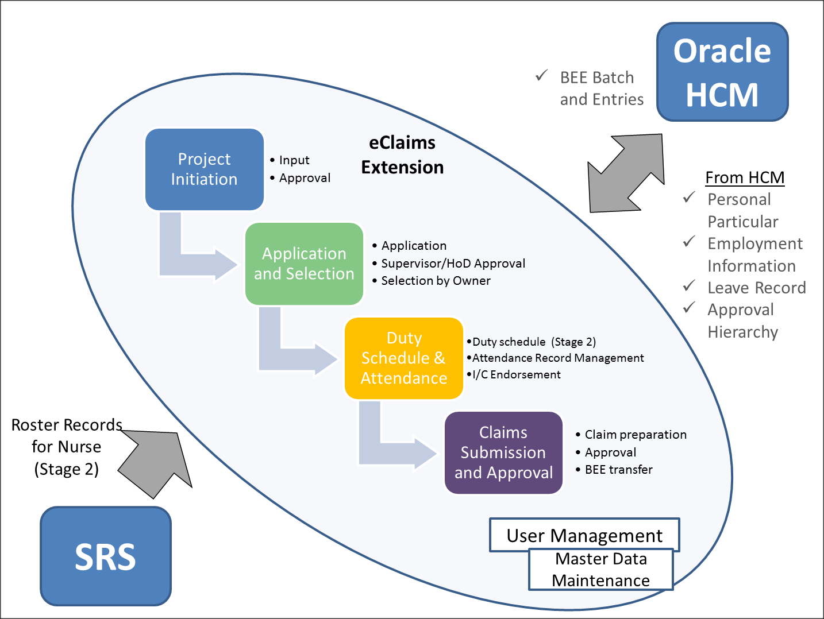

eClaim will be a standalone system which will integrate with different systems by interfaces/web services. eClaim consists of four sub modules.

1. Project initiation (Phase 1)

Project information and subsequent approval flow are included in the sub module.

1. Application and selection (Phase 2)
2. Duty schedule & attendance (Phase 2)
3. Claims submission & approval (Phase 1)

The project will be developed in two phases.

Phase 1 will cover two sub-modules: i. Project Initiation, ii. Claims Submission & Approval. Bulk Upload functionality is required in Phase 1 to upload attendances / claims records into Claims module for subsequent approval and payment process.

Phase 2 will cover the remaining modules: i. Application and selection ii. Duty Schedule & Attendance. However, these are out of the current scope of the Service Request SR2018040.

## Project Initiation (Phase 1)

### Access Control

Each project role could access project under their access rights. All the functions/pages in eClaim system should follow same access controls except explicitly mentioned.

|  |  |
| --- | --- |
| Role | Description |
| Project Owner | Access all the projects owned by login user |
| Project Coordinator | Access all the projects with login user as one of project coordinators  If the concerned project has more than one project coordinator, login user could access job assigned to her |
| Project Preparer | Access all the projects with login user as the project preparer |
| HR User | Access all the projects under the same cluster |
| HR Manager | Access all the projects under the same cluster |
| FIN Admin | Access all the projects under the same cluster |
| FIN Hospital I/C | Access all the projects under the same cluster |
| Payroll Officer | Access all the projects under the same cluster |
| Payroll Manager | Access all the projects under the same cluster |
| Claim Prepare | Access all the projects with login user as one of claim preparers |
| Claim Approver | Access all the projects with login user as one of claim approvers |
| Roster Planner | Access all the project/Department/Ward with login user as one of roster planner |
| Duty in Charge | Access all the projects/job with login user as one of duty in charges |

### Process Flow (New Project)

1. Project preparer input all the information required into the system and submits the draft to project owner for review
2. Project owner reviews the drafted project and submit the project for HR vetting
3. Cluster HR vets the HR related information (e.g. manpower shortage description) in the project
4. Cluster FIN administrator verifies the budget / COA information
5. Cluster FIN hospital in charge confirms the financial impact
6. Cluster HR gathers all approval documents outside system and approve the project on behalf managements with supporting documents uploading to the system

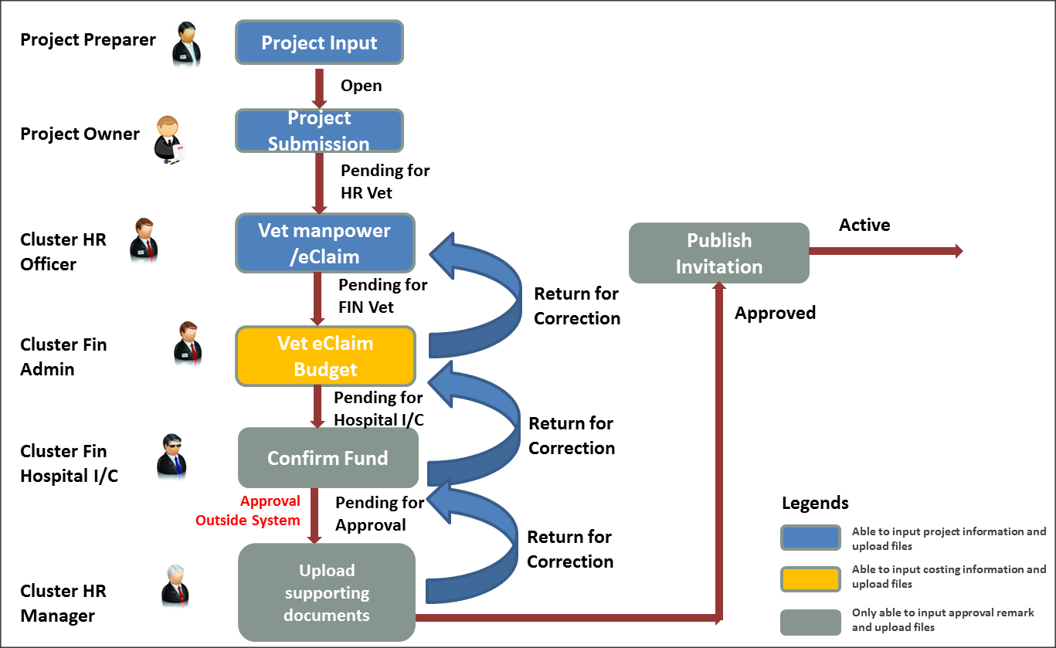

### Process Flow (Update Project)

1. Cluster HR vets the HR related information (e.g. manpower shortage description) in the project
2. Cluster FIN administrator verifies the budget / COA information
3. Cluster FIN hospital in charge confirms the financial impact
4. Cluster HR gathers all approval documents outside system and approve the project on behalf managements with supporting documents uploading to the system

### Process Flow (Update COA Only)

1. Cluster FIN administrator update COA information
2. Cluster FIN hospital in charge confirms the change

### Landing Page

The roles below will use project search screen as landing page.

* Project Owner
* Project Coordinator
* Project Preparer
* HR User
* HR Manager
* FIN Admin
* FIN Hospital I/C
* Payroll Officer
* Payroll Manager

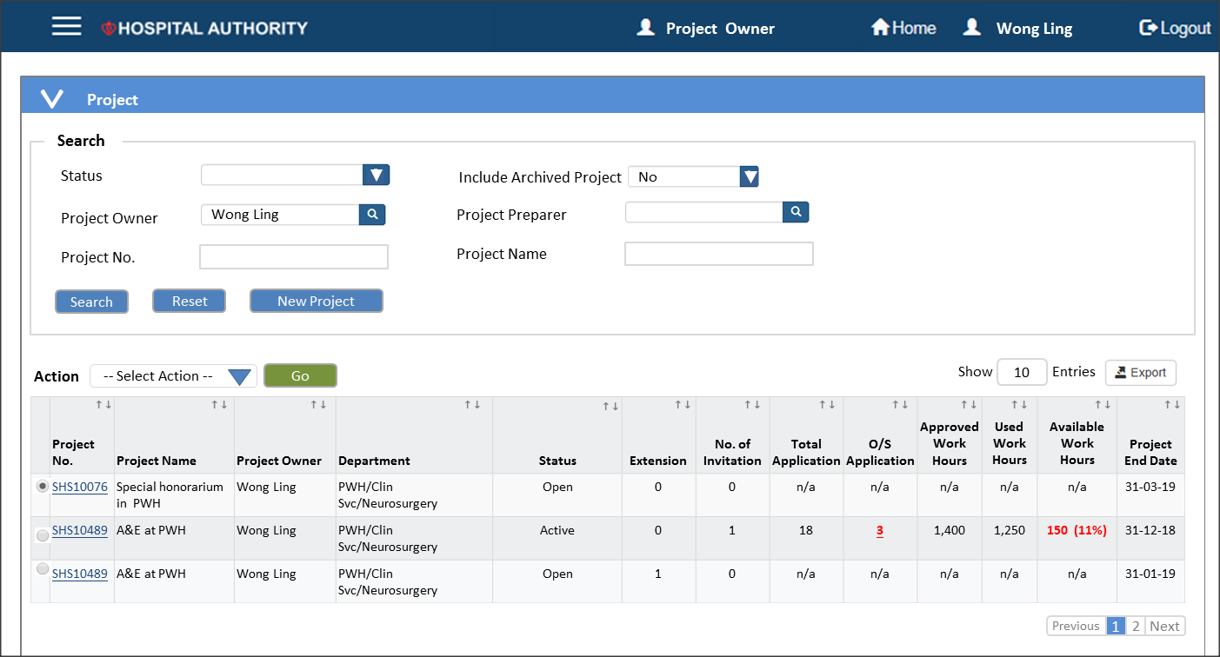

### Project Status Summary

|  |  |  |
| --- | --- | --- |
| **Status** | **To System Role** | **Remarks** |
| Saved | n/a | New project is saved but yet to transfer to project owner for review. |
| Open | Project Owner | New project is transferred to project owner for review |
| Pending for HR Vet | HR Officer | New project is submitted by project owner and pended for HR vetting |
| Pending for FIN Vet | FIN Admin | New project is vetted by HR and pended for FIN vetting |
| Pending for Hospital I/C | FIN Hospital I/C | New project is vetted by FIN admin and pended for hospital I/C confirmation |
| Pending for Approval | HR Manager | New project is vetted by both FIN and HR.  HR manager will approve the project on behalf of senior management |
| Approved | n/a | Project is approved and ready for new invitation |

### Project Input

User could create new project initiation by either “New Project” item on the left panel or “New” button in the project window.

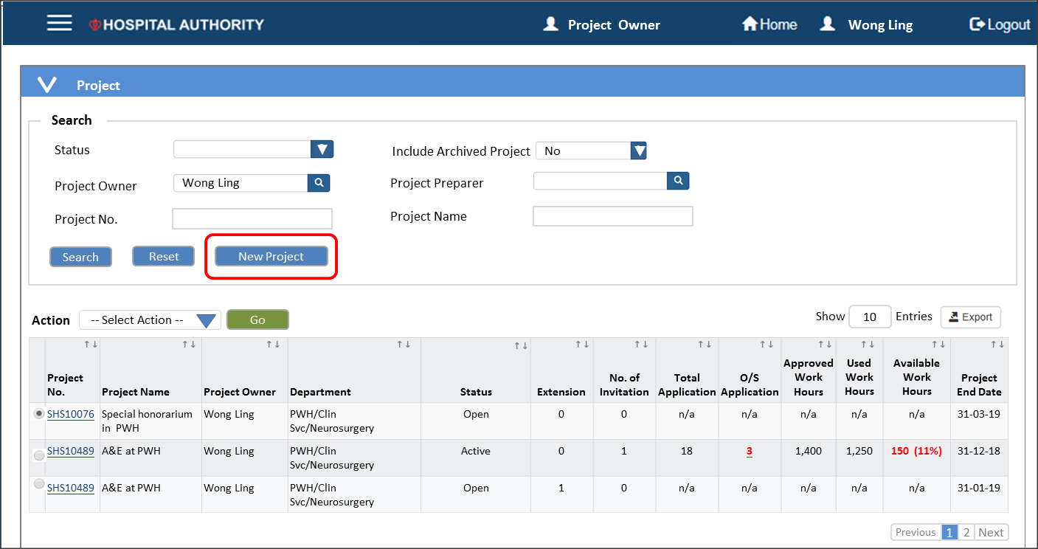

| **#** | **Data Element** | **Definition** | **Criticality** | **Input Method** | **Remarks** |
| --- | --- | --- | --- | --- | --- |
| 1. 1 | Project No. | Generated sequence once saved or sent to project owner | n/a | n/a | Click to open project |
|  | Project Name | Information from project | n/a | n/a |  |
|  | Project Owner | Information from project | n/a | n/a |  |
|  | Department | Information from project | n/a | n/a |  |
|  | Status | Refer to 2.5 project status summary | n/a | n/a |  |
|  | Extension | No. of extension | n/a | n/a | May need to add a project extension flag during extension |
|  | No. of invitation | No. of invitation created | n/a | n/a |  |
|  | Total Applications | Total no. of application | n/a | n/a |  |
|  | o/s Application | Outstanding no. of application | n/a | n/a |  |
|  | Approved Working Hours |  | n/a | n/a |  |
|  | Used Working Hours |  | n/a | n/a | No. of working hours that   * Actual used with attendance records * Pended work hour which confirmed in schedule |
|  | Available Working Hours |  | n/a | n/a | = approved working hours – used working hours |
|  | Project Start Date | Information from project | n/a | n/a |  |
|  | Project End Date | Information from project | n/a | n/a |  |

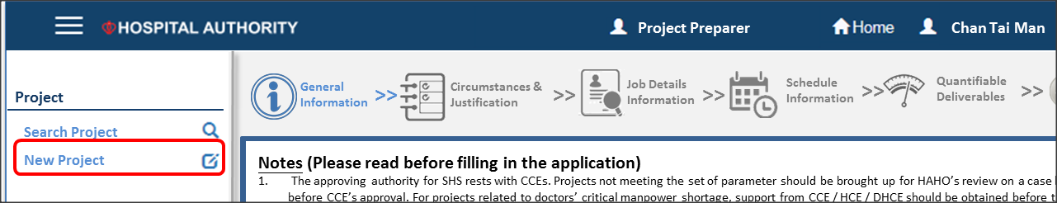

Project input consists of six parts

1. Input general information
2. Input circumstance and justifications
3. Input post detail information
4. Input schedule information
5. Input quantifiable deliverables
6. Review project
   * 1. (a) Disclaimer and General Information

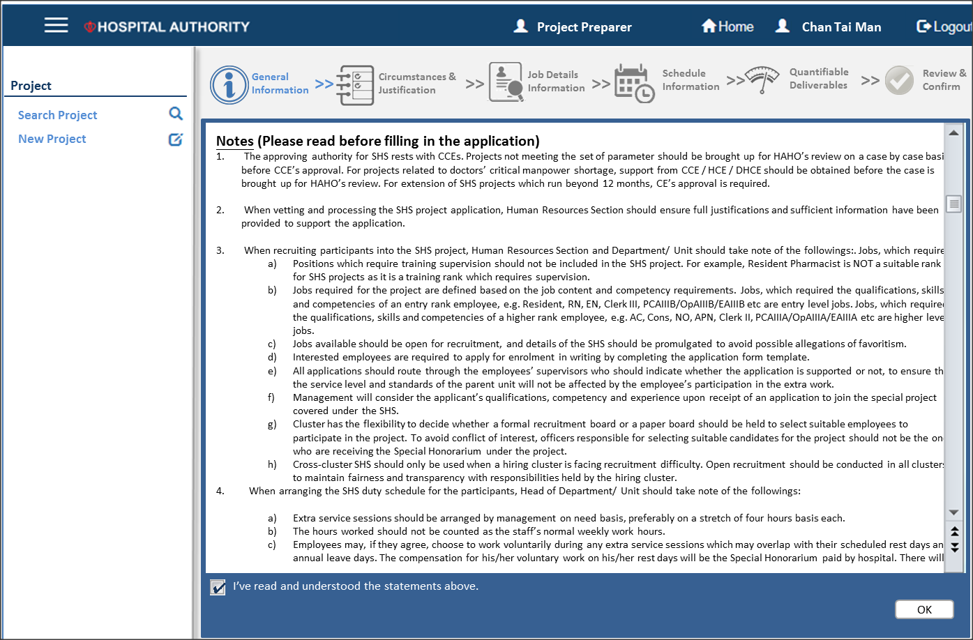

Disclaimer screen

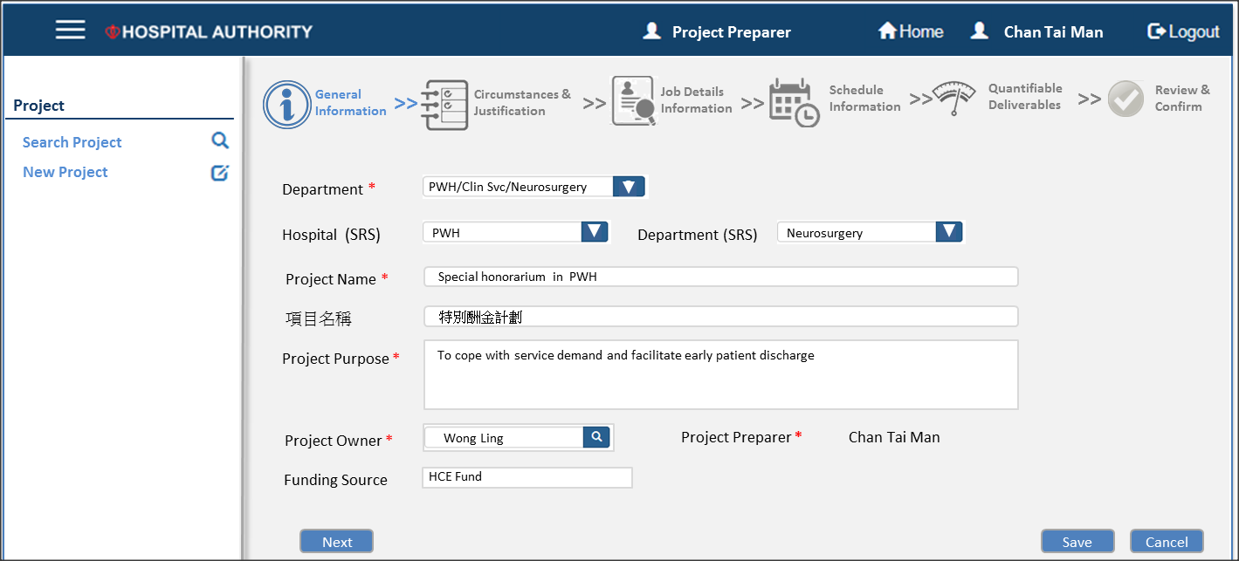

General information screen

|  |  |  |  |  |  |
| --- | --- | --- | --- | --- | --- |
| **#** | **Data Element** | **Definition** | **Criticality** | **Input Method** | **Remarks** |
| 1 | Department | Department performs the SHS | Mandatory | List of Values | Use HCM level 5 organization.  *<Refer to* ***Appendix*** *for the full list>* |
| 2 | Hospital (SRS) | If SRS mapping is known, user input these two fields for roles defaulting | Optional | List of Values | Daily roster interface from SRS. Refer to integration with SRS system |
| 3 | Department (SRS) |  |
| 4 | Project Name | Name of the SHS project | Mandatory | Free Text |  |
| 5 | 項目名稱 | Chinese name of the SHS project | Optional | Free Text | It is used for supporting staff. |
| 6 | Project Purpose | Purpose of the project | Mandatory | Free Text |  |
| 7 | Project Owner | Owner of the project | Mandatory | List of Values | Full list of active employee.  Must input search criteria to prevent heavy SQL |
| 8 | Project Preparer |  | Mandatory |  | System will default creator of the project initiation as project preparer |
| 9 | Funding Source | Source of funding | Mandatory | Free Text |  |

* + 1. (b) Circumstances & Justifications

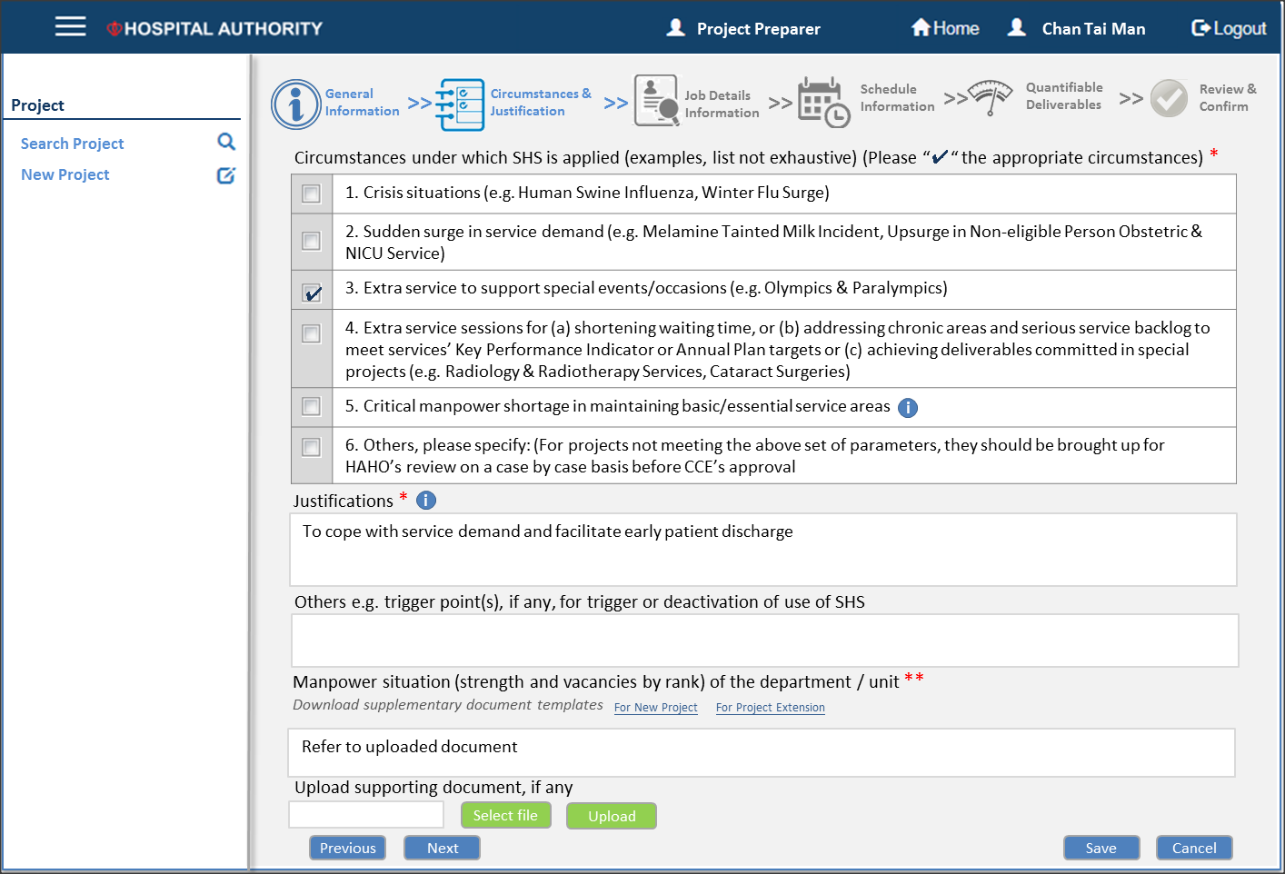

|  |  |  |  |  |  |
| --- | --- | --- | --- | --- | --- |
| **#** | **Data Element** | **Definition** | **Criticality** | **Input Method** | **Remarks** |
|  | Circumstances | Circumstances under which SHS applied | Mandatory | Check box | This could be maintained by HOHR |
|  | Justifications | Justifications of the project | Mandatory | Free Text |  |
|  | Others | Trigger point(s) or deactivation of SHS | Optional |  |  |
|  | Manpower shortage detail | In case of manpower shortage, detail current manpower information is required | Optional |  | Mandatory only for the case of manpower shortage |
|  | Upload supporting documents | Upload supporting documents | Optional |  |  |

* + 1. (c) Input post detail information

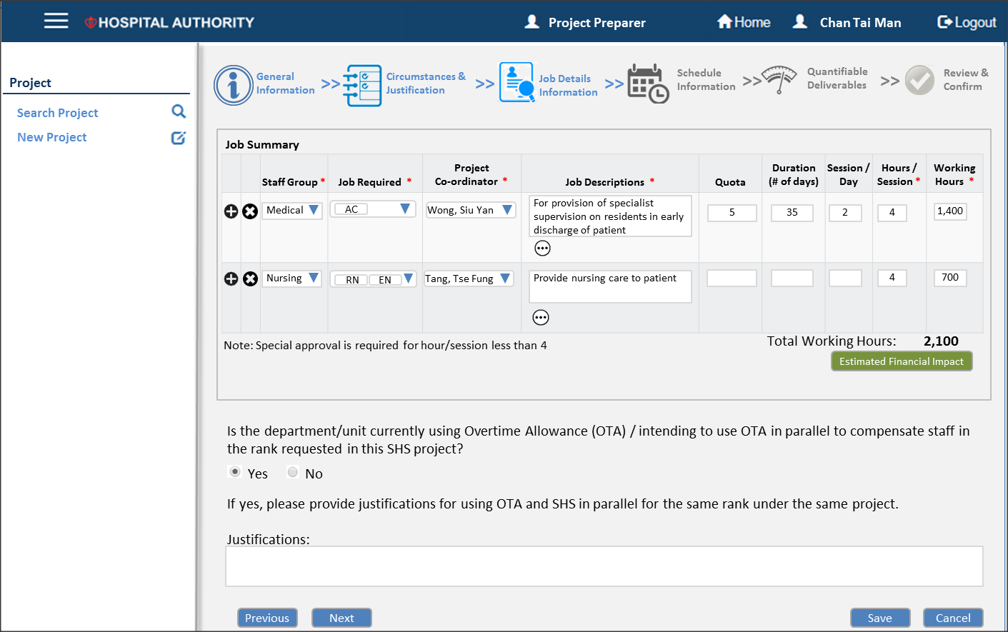

|  |  |  |  |  |  |
| --- | --- | --- | --- | --- | --- |
| **#** | **Data Element** | **Definition** | **Criticality** | **Input Method** | **Remarks** |
|  | Staff Group | Staff group | Mandatory | List of Values | Available in HCM |
| 1. 1 | Job Required | Job(s) required (Allow multiple selection) | Mandatory | List of Values | List maintained by HO Administrator |
| 1. 2 | Project Coordinator | This role could help project own to select candidate | Mandatory | List of Values | Full list of active employee.  Must input search criteria to prevent heavy SQL |
| 1. 3 | Job Descriptions |  | Mandatory | Free Text |  |
| 1. 4 | Quota | No. of staff | Optional | Number |  |
| 1. 5 | Duration | No. of days | Optional | Number |  |
| 1. 6 | Session/day | No. of session per day | Optional | Number |  |
|  | Hours/session | No. of hours per day | Mandatory | Number |  |
|  | Total working hour | Total working hour of this rank group | Mandatory | Number | If quota, duration, hours/session and session/day are input, working hour will be  ***Working hour = quota x duration x session/day x hours/session***  Working hour will be unable to update in this case |
|  | OTA is enabled? |  | Mandatory | Yes/No |  |
|  | Justification |  | Mandatory if OTA is enabled | Free Text |  |

**If “Detail” button is clicked, a pop-up window will be shown and allows user to provide comprehensive job requirements as below.**

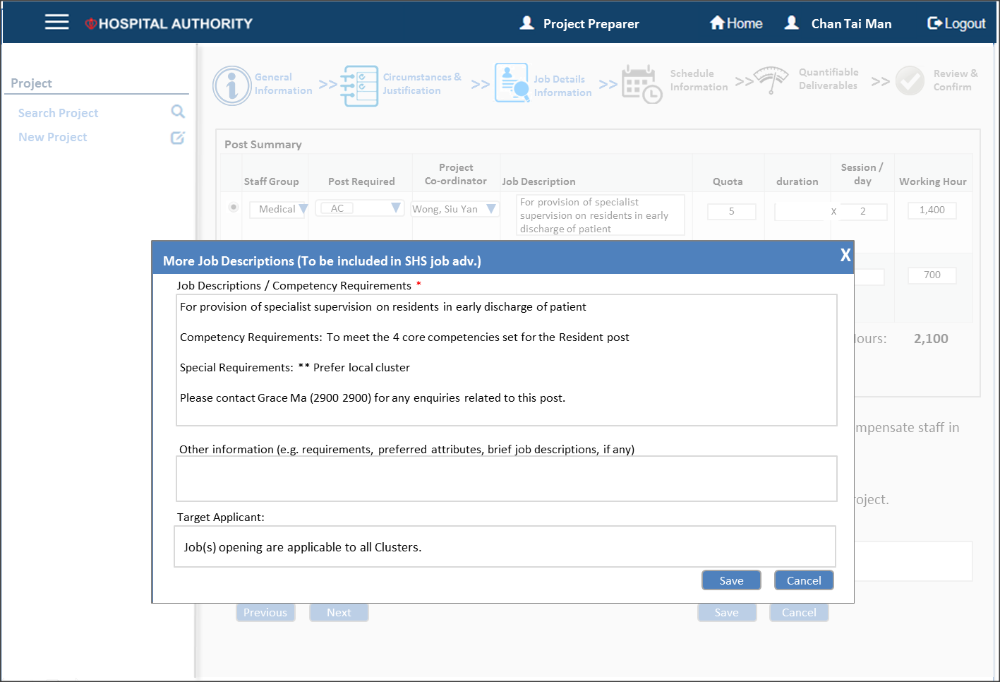

|  |  |  |  |  |  |
| --- | --- | --- | --- | --- | --- |
| **#** | **Data Element** | **Definition** | **Criticality** | **Input Method** | **Remarks** |
| 1. 1 | Job Description/ Competency Requirement |  | Mandatory | Free text |  |
|  | Other information |  | Optional | Fee text |  |
|  | Target Applicant |  | Optional | Free text |  |

* + 1. (d) Input schedule information

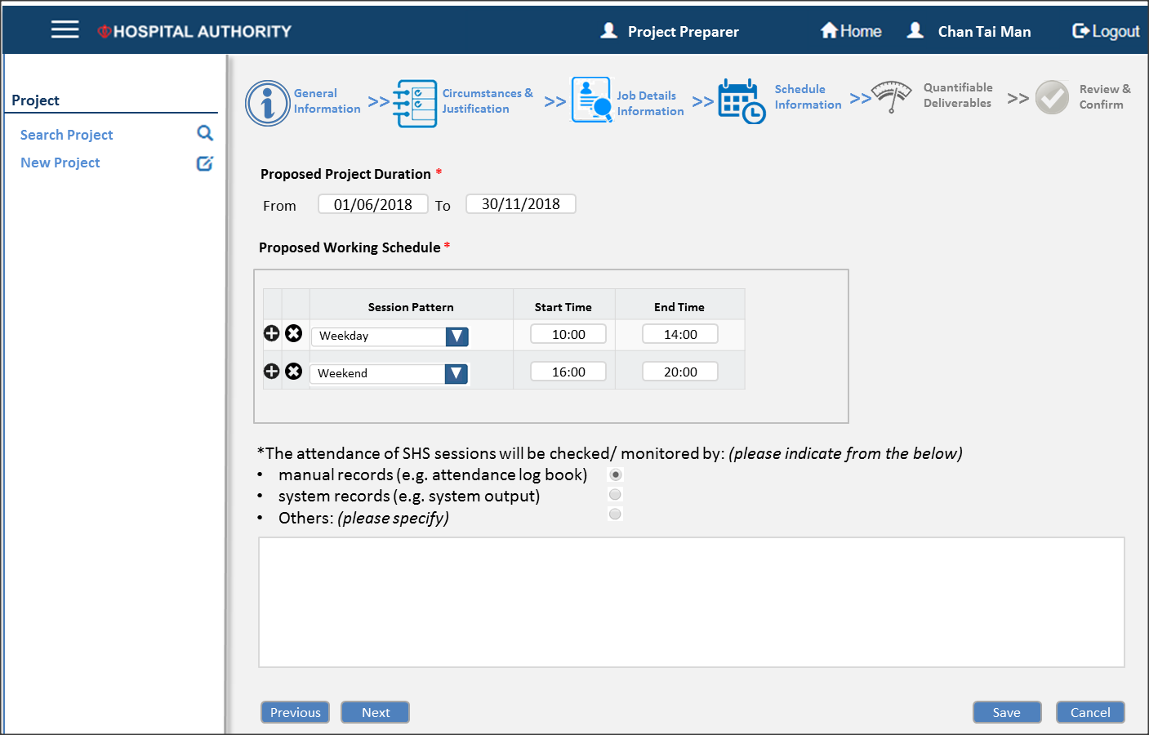

|  |  |  |  |  |  |
| --- | --- | --- | --- | --- | --- |
| **#** | **Data Element** | **Definition** | **Criticality** | **Input Method** | **Remarks** |
| 1. 1 | Proposed Project Duration From |  | Mandatory | Date |  |
| 1. 2 | Proposed Project Duration To |  | Mandatory | Date |  |
| 1. 3 | Session Pattern | Pattern of the particular session (e.g. every weekend) | Mandatory | List of Values | Available values   * Weekend * Weekday * Everyday |
| 1. 4 | Session Start Time |  | Mandatory | List of Values | Available values are  Every hour on the :00 minute and :30 minute |
| 1. 5 | Session End Time |  | Mandatory | List of Values |
|  | Mode of attendance records |  | Mandatory | List of Values | Available values   * Manual records * System records * Other   If “Other” is chosen, user need to further specify. |

* + 1. (e) Input quantifiable deliverables information

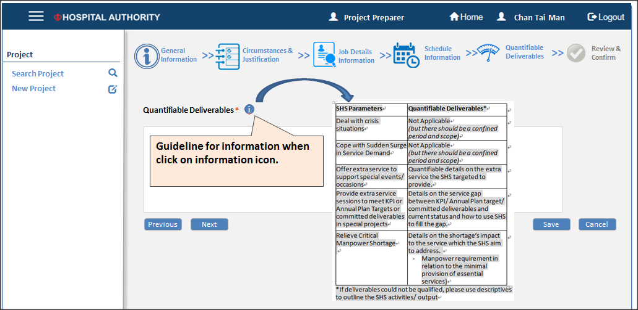

|  |  |  |  |  |  |
| --- | --- | --- | --- | --- | --- |
| **#** | **Data Element** | **Definition** | **Criticality** | **Input Method** | **Remarks** |
| 1. 1 | Quantifiable deliverables |  | Mandatory | Free Text |  |

* + 1. (f) Review Information

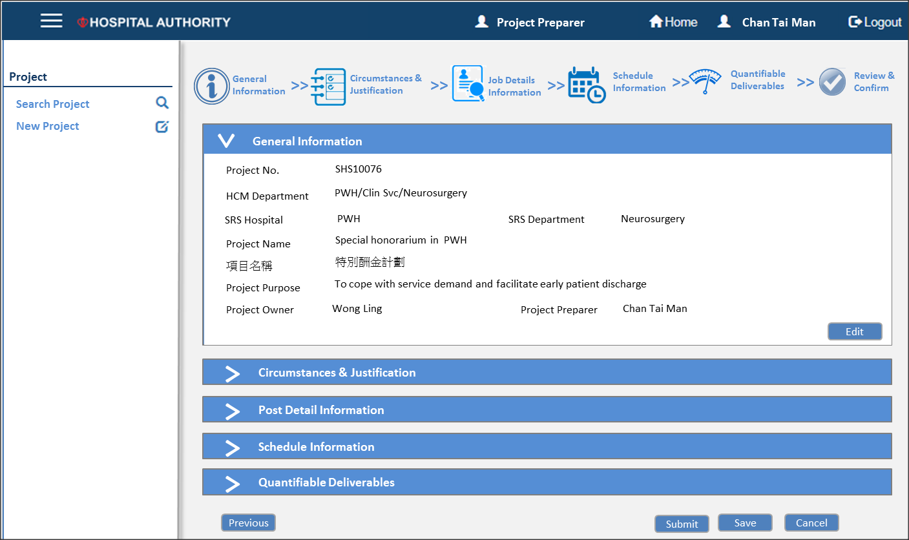

No input is required in this page

* + 1. (g) Email notification

Notification will send to project owner and project coordinators. Email subject and content could not be updated. Instead, user could supplement information in the “Supplement” section.

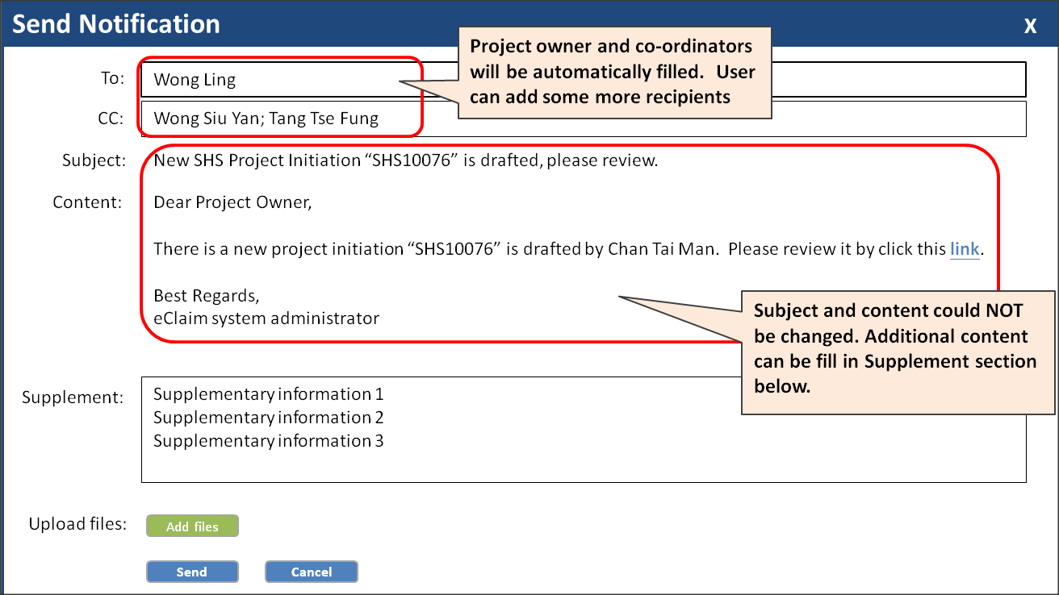

### Project Owner Review and Submit

Screen flow is almost identical to project preparer. Project owner

* Declare the SHS comply with the policy
* Update the project detail if any
* Submit for HR Vetting after reviewing project initiation

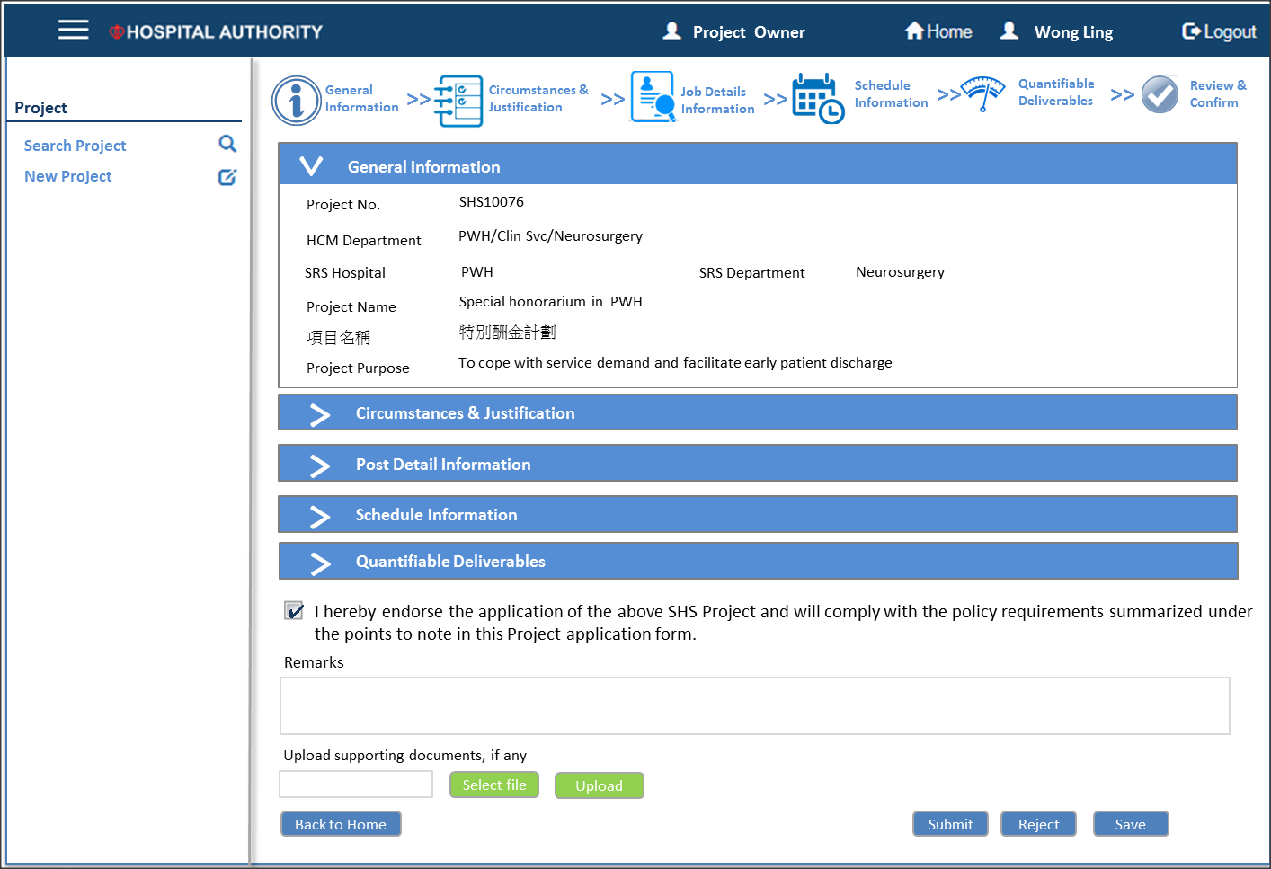

Notification will send to all HR Officer in the cluster. Email subject and content could not be updated. Instead, user could supplement information in the “Supplement” section.

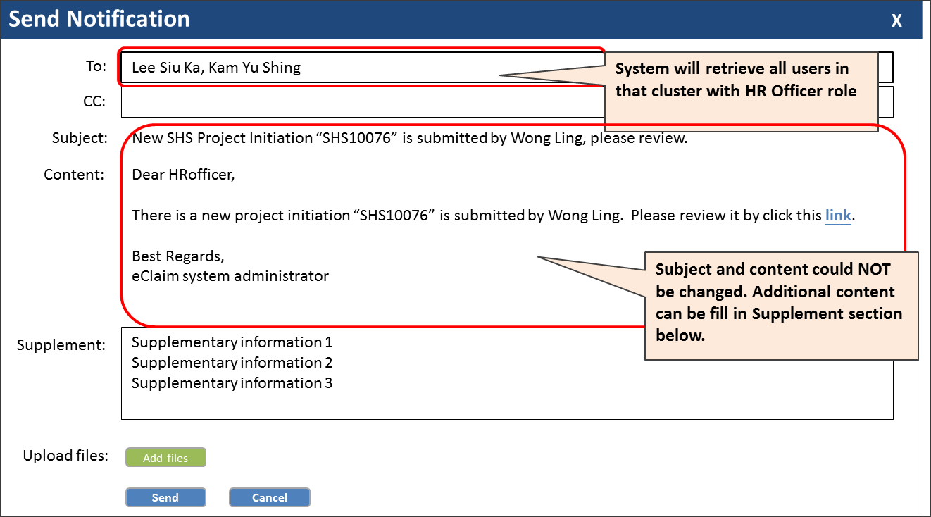

### HR Vet by HR Officer

Screen flow is almost identical to project preparer. HR Officer

* Update the project detail if any
* Submit for HR Vetting after reviewing project initiation

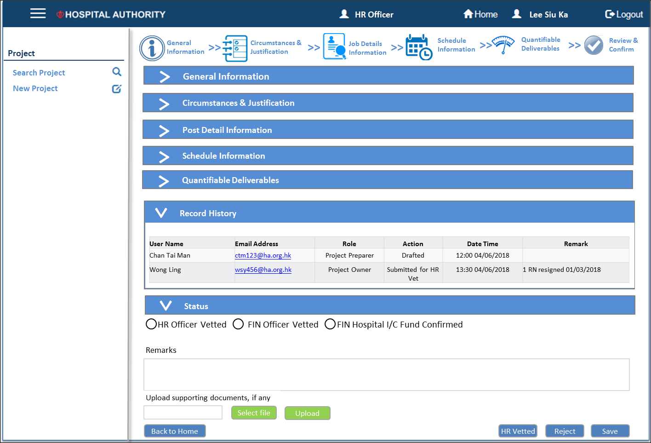

*Note: “Request for information” should be done outside eClaim system*

Notification will send to all FIN Admin in the cluster. Email subject and content could not be updated. Instead, user could supplement information in the “Supplement” section.

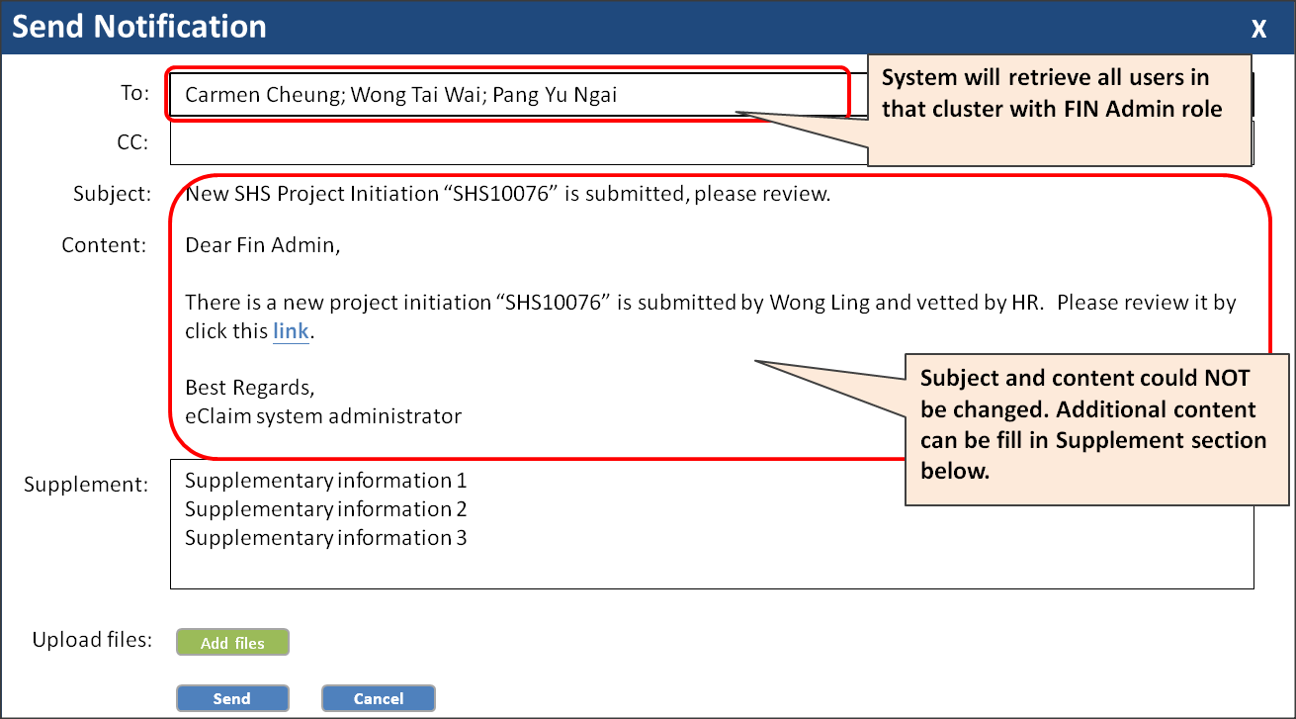

### FIN Vet by FIN Admin

FIN cannot update project initiation information **EXCEPT finance information** like

* Choose “FIN Hospital I/C”
* Cost calculation method (NAMS / Maximum)
* Chart of Accounts (COA)

They could either

* Return for Correction
* FIN Vet
* Reject

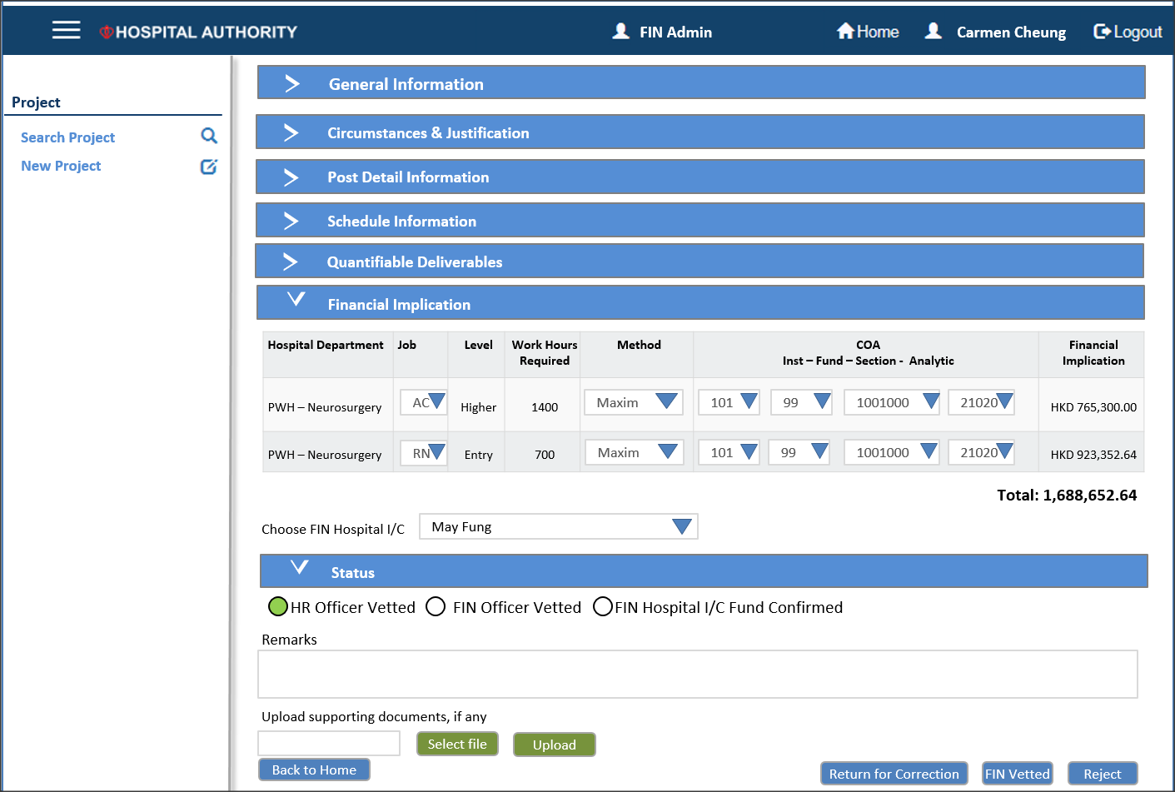

Notification will send to all FIN Hospital I/C in the cluster. Email subject and content could not be updated. Instead, user could supplement information in the “Supplement” section.

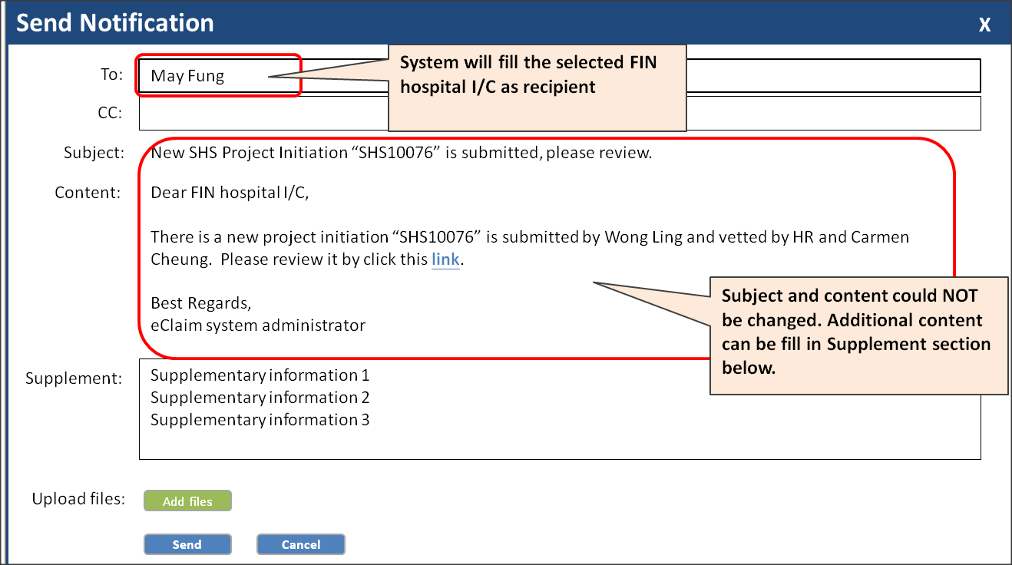

### FIN Hospital I/C confirm fund

FIN hospital I/C cannot update project initiation information, instead, they could review the financial information and perform one of the following action

* Return for Correction
* Confirm Fund
* Reject

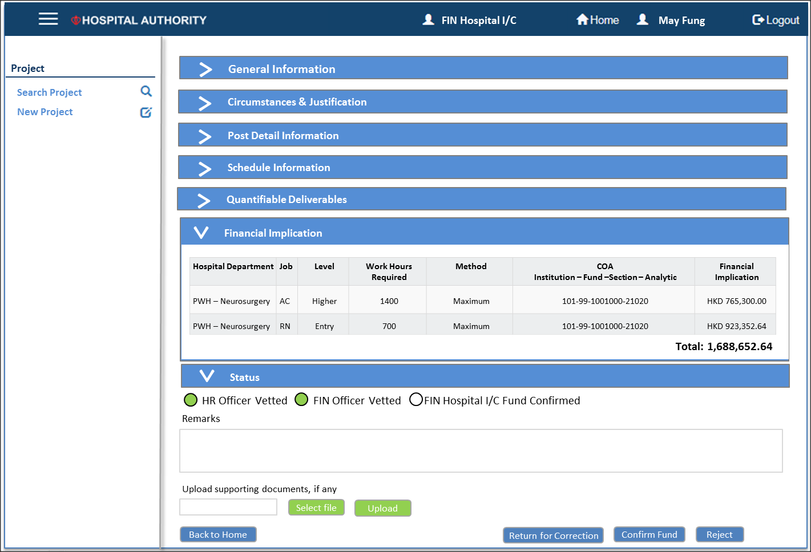

Notification will send to all HR Manager in the cluster. Email subject and content could not be updated. Instead, user could supplement information in the “Supplement” section.

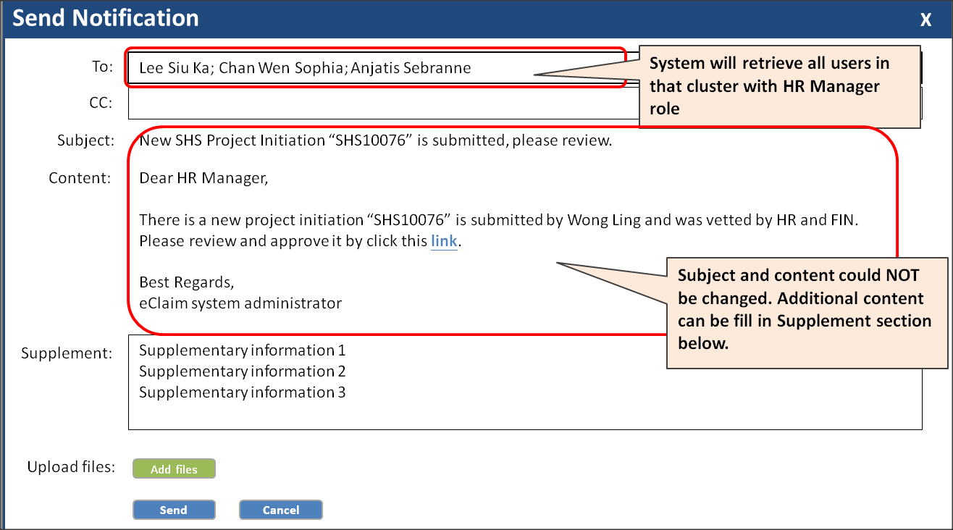

### HR Manager Approve the Project Initiation on Behalf of Management

In order to streamline the process and ensure control being in place, it is suggested approval is done by HR on behalf of management. HR manager is required to upload all the related approval documents (e.g. approval email / scanned copy). HR should perform one of the following action

* Return for Correction
* Approve
* Reject

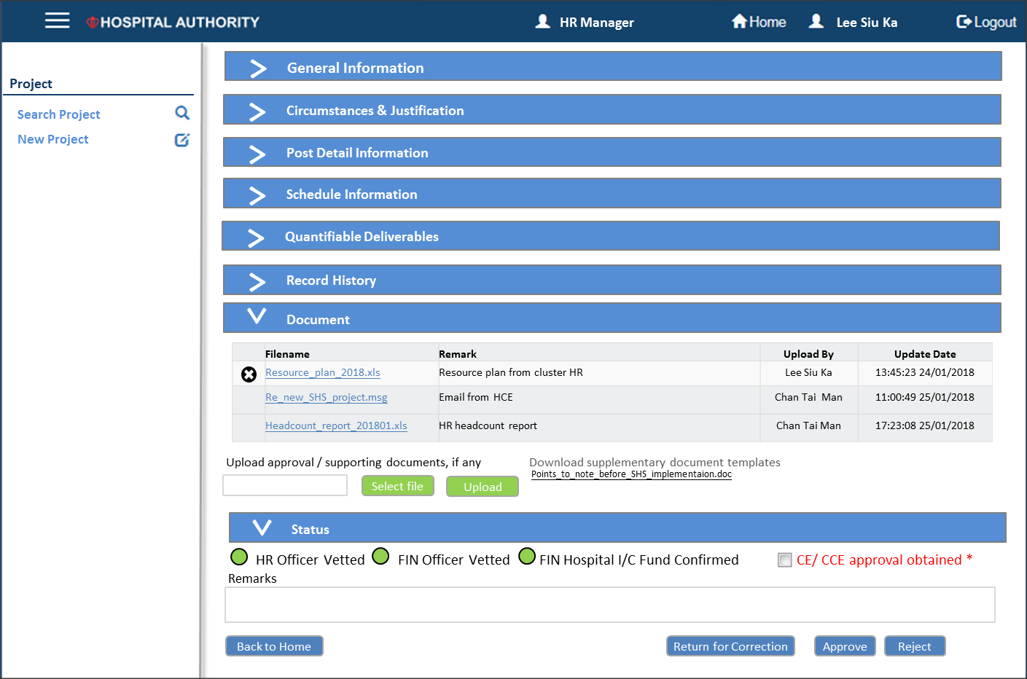

Notification will send to all concerned parties involved in the project creation/approval process. Email subject and content could not be updated. Instead, user could supplement information in the “Supplement” section. Other information could be uploaded and attached to email.

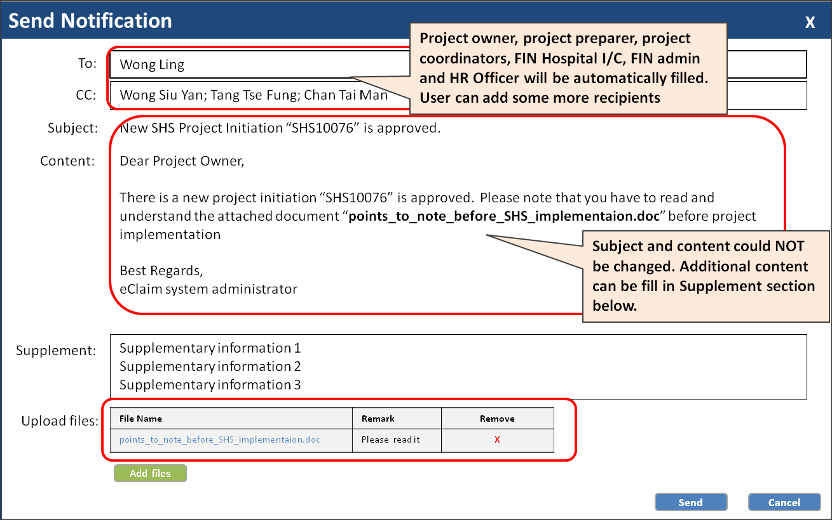

### HR Publish Job (Phase 2)

After approval, HR User could publish the job on HR app through publish function

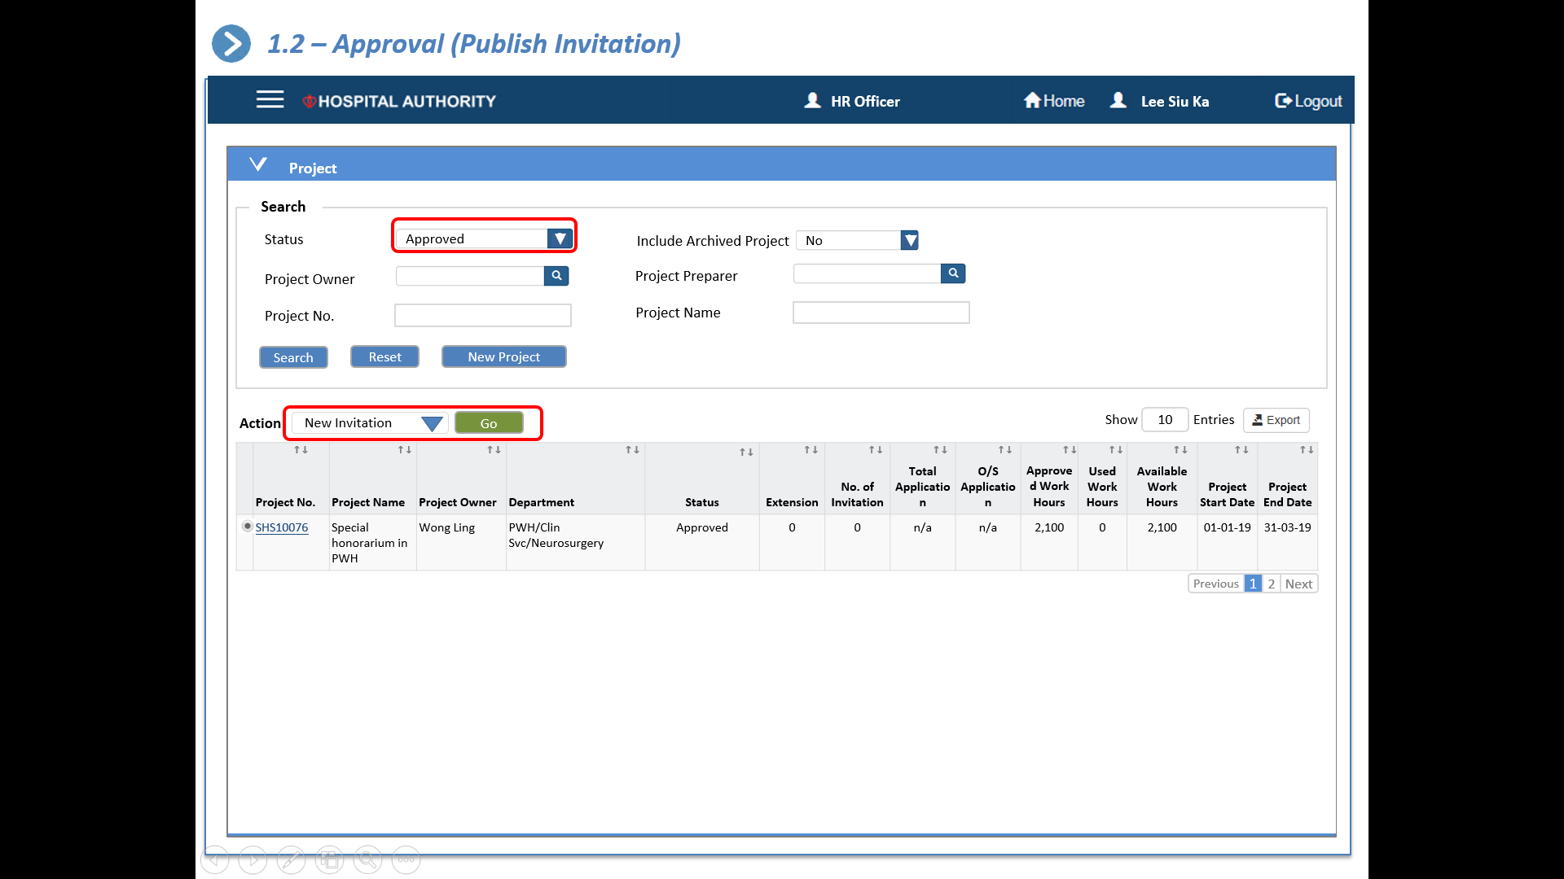

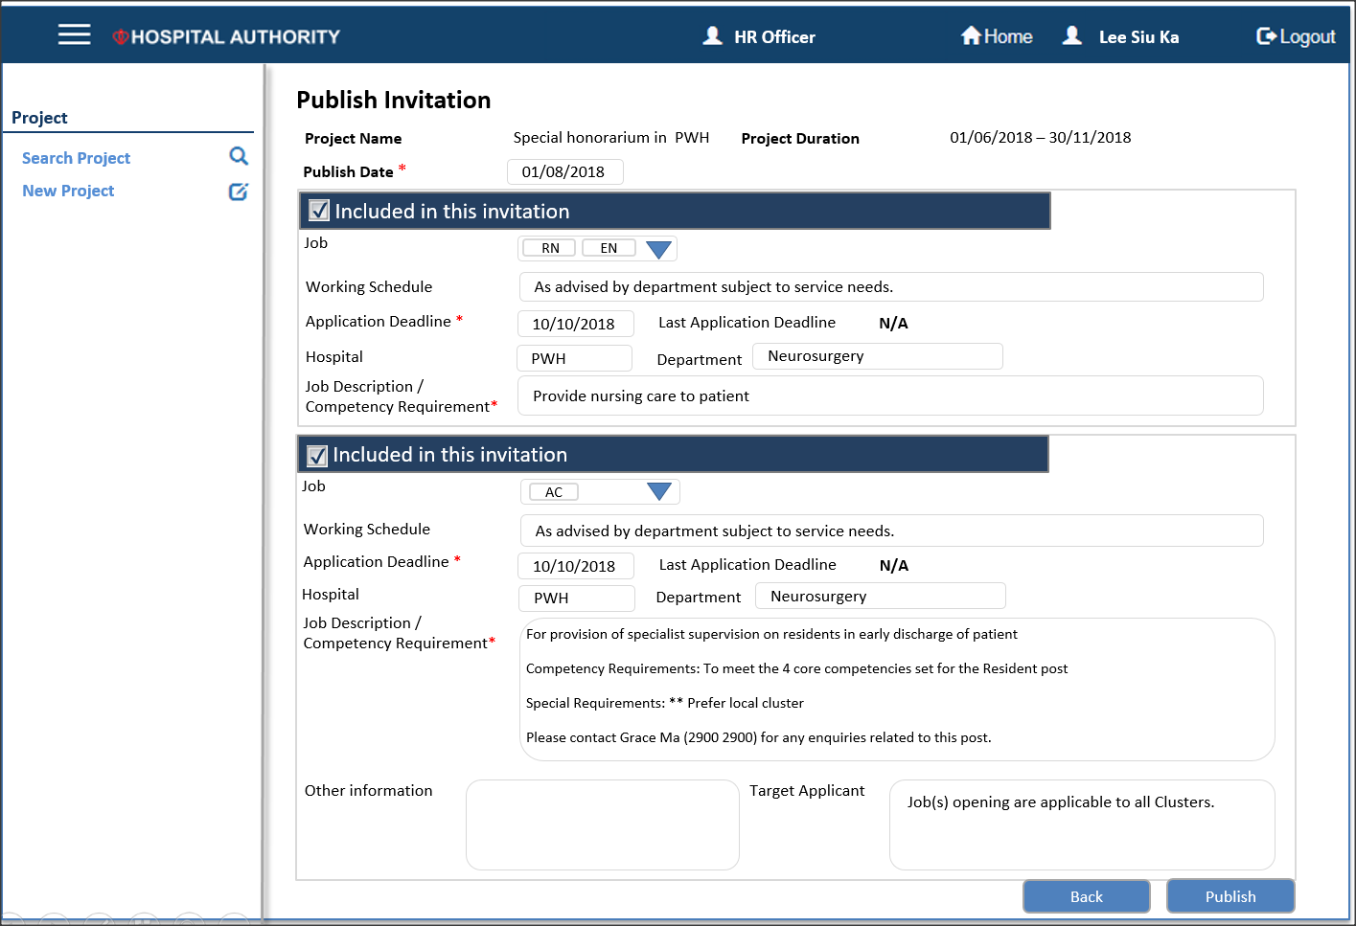

|  |  |  |  |  |  |
| --- | --- | --- | --- | --- | --- |
| **#** | **Data Element** | **Definition** | **Criticality** | **Input Method** | **Remarks** |
|  | Project Name | Source: Project information |  | N/A |  |
|  | Project Duration | Source: Project information |  | N/A |  |
|  | Publish Date |  |  | Date | Job advertisement publish date |
|  | Job | Value defaulted from project information |  | List of Values |  |
|  | Working Schedule | Value defaulted from project information |  | Free Text |  |
|  | Application Deadline |  |  | Date |  |
|  | Hospital | Value defaulted from project information |  | List of Values |  |
|  | Department | Value defaulted from project information |  | List of Values |  |
|  | Job Descriptions / Competency Requirement | Value defaulted from project information |  | Free Text |  |
|  | Other information | Value defaulted from project information |  | Free Text |  |
|  | Target Applicant | Value defaulted from project information |  | Free Text |  |

### Other Actions

* + 1. Copy Project

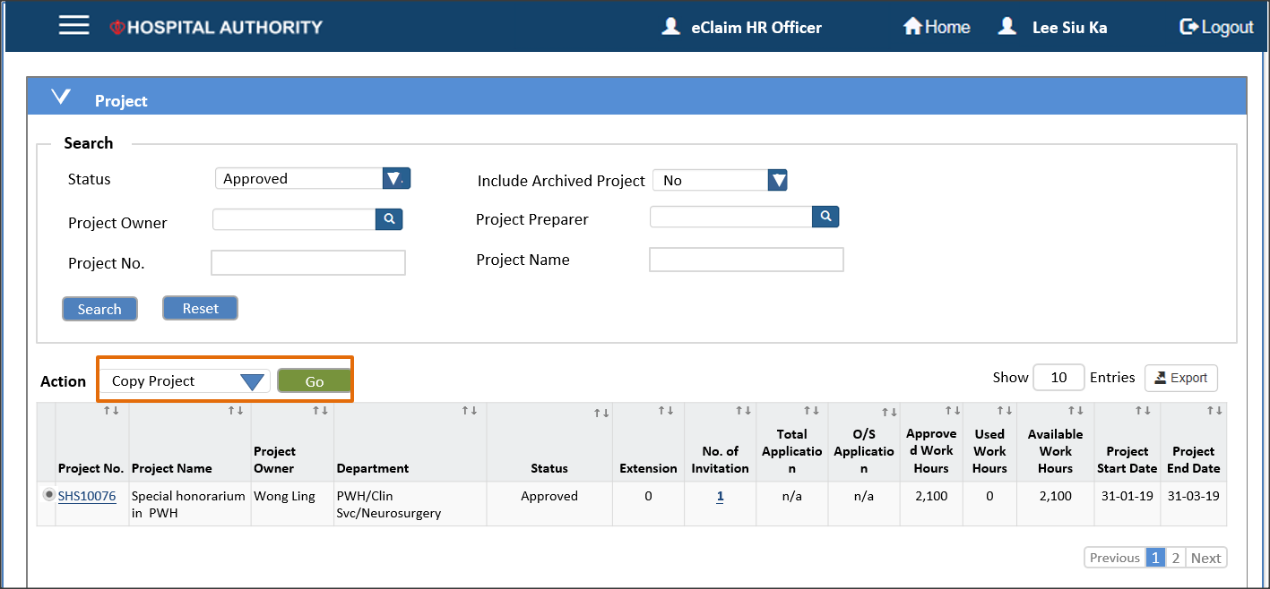

System supports copy from existing projects to enhance user experience while creating similar project.

* + 1. Update Project

Project update is possible after approved due to different reasons. System should support this function (refer to 2.2 / 2.3 for the update process flow). Please note that any update should be kept as a revision and allow user to keep track all revisions of the same project.

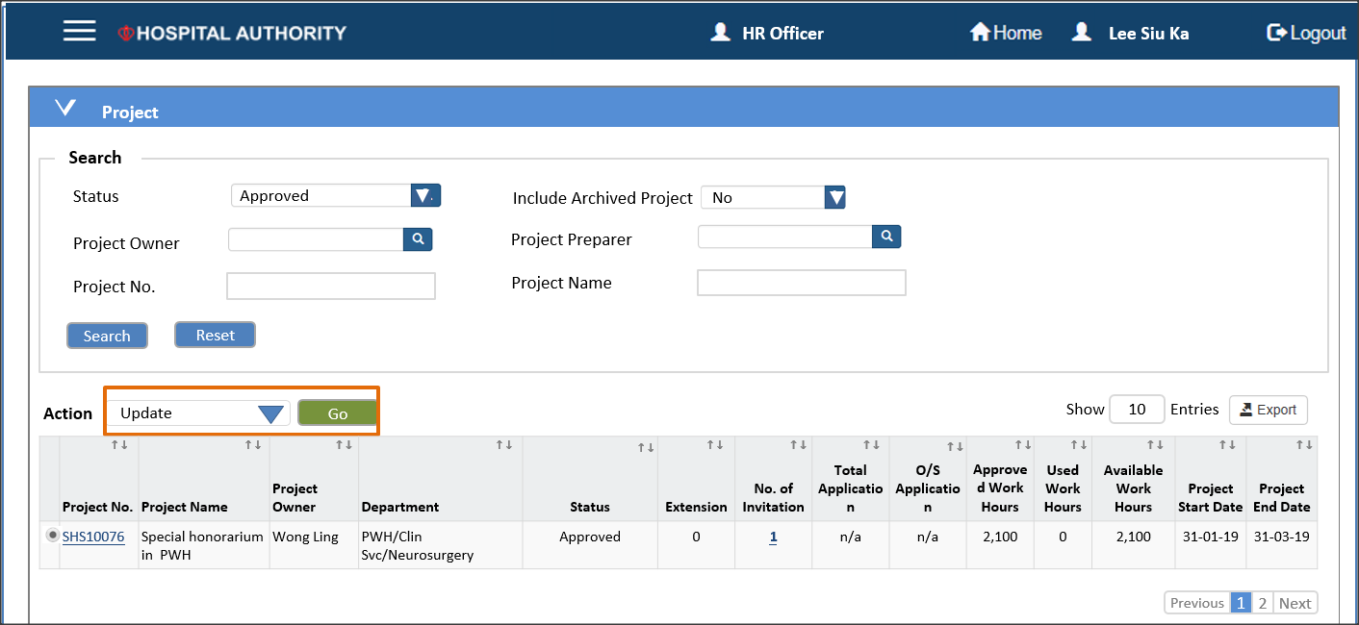

1. HR Officer could update all information except the following
   * Department
   * Project Name

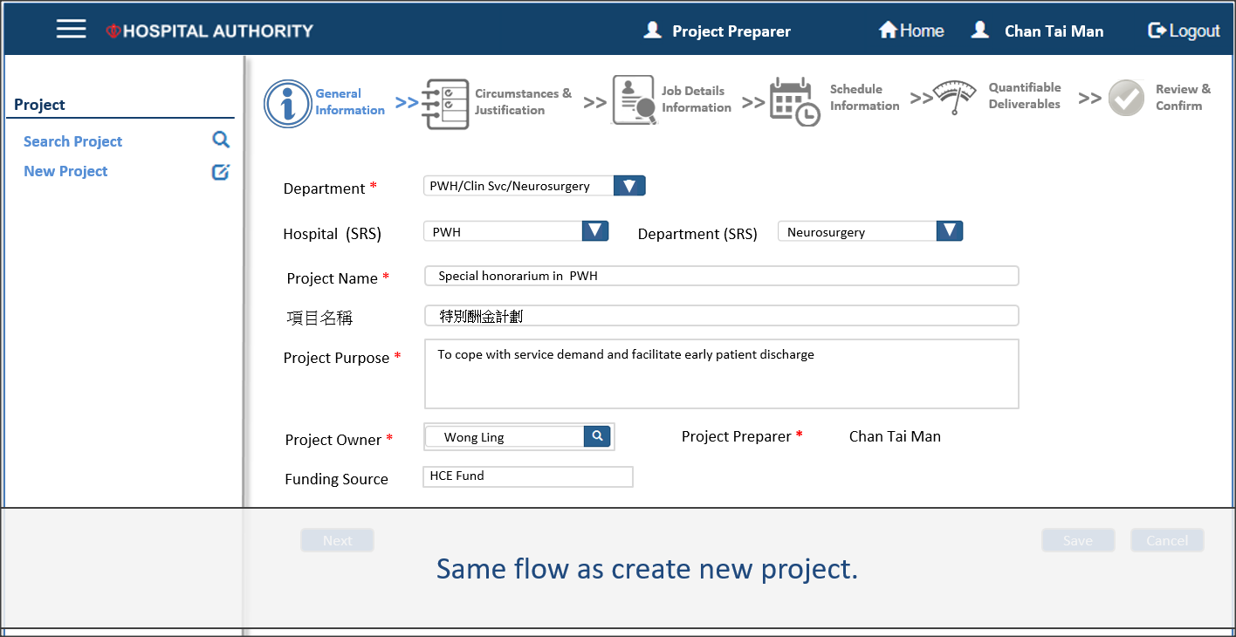

* + 1. Assign Project Roles

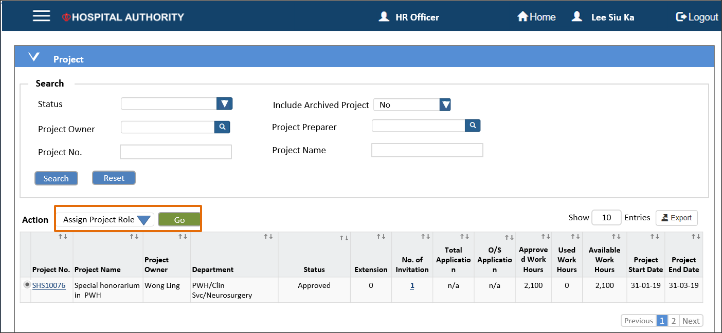

Project coordinator / owner could assigns the project roles either

* 1. Find individual employee by Corp ID

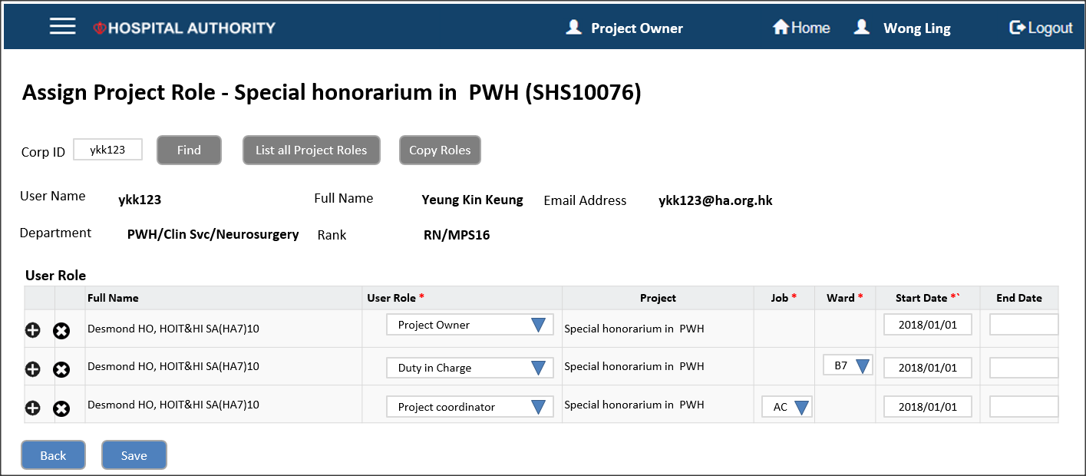

|  |  |  |  |  |  |
| --- | --- | --- | --- | --- | --- |
| **#** | **Data Element** | **Definition** | **Criticality** | **Input Method** | **Remarks** |
| 1. 1 | Corp ID |  | Mandatory | Free Text |  |
|  | Full Name |  | n/a | n/a | Display only – Full name from HCM |
|  | User Role |  | Mandatory | List of Values |  |
|  | Project |  | n/a | n/a | Display only |
|  | Job |  | Mandatory if user role is “Project Coordinator” | List of Values | Values get from job/rank group in project initiation |
|  | Ward |  | Mandatory if user role is “Duty in Charge” | List of Values | Values get from session creation under the same project |
|  | Start Date |  | Mandatory | Date |  |
|  | End Date |  | Optional | Date |  |

* 1. List all employees assigned to the selected project

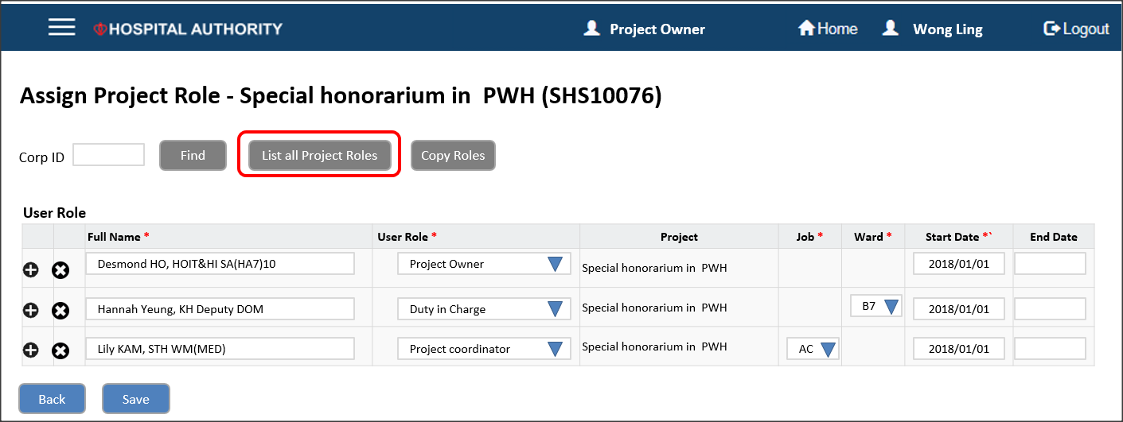

|  |  |  |  |  |  |
| --- | --- | --- | --- | --- | --- |
| **#** | **Data Element** | **Definition** | **Criticality** | **Input Method** | **Remarks** |
|  | Full Name |  | Mandatory | List of Values | Search by Corp email title |
|  | User Role |  | Mandatory | List of Values |  |
|  | Project |  | n/a | n/a | Display only |
|  | Job |  | Mandatory if user role is “Project Coordinator” | List of Values | Values get from job/rank group in project initiation |
|  | Ward |  | Mandatory if user role is “Duty in Charge” | List of Values | Values get from session creation under the same project |
|  | Start Date |  | Mandatory | Date |  |
|  | End Date |  | Optional | Date |  |

* 1. Copy roles from other projects

Provide function to copy roles from other projects to minimize user inputs.

* + 1. Print Project

System provides function to print the project detail in predefined format (Will be confirmed in solution confirmation phase)

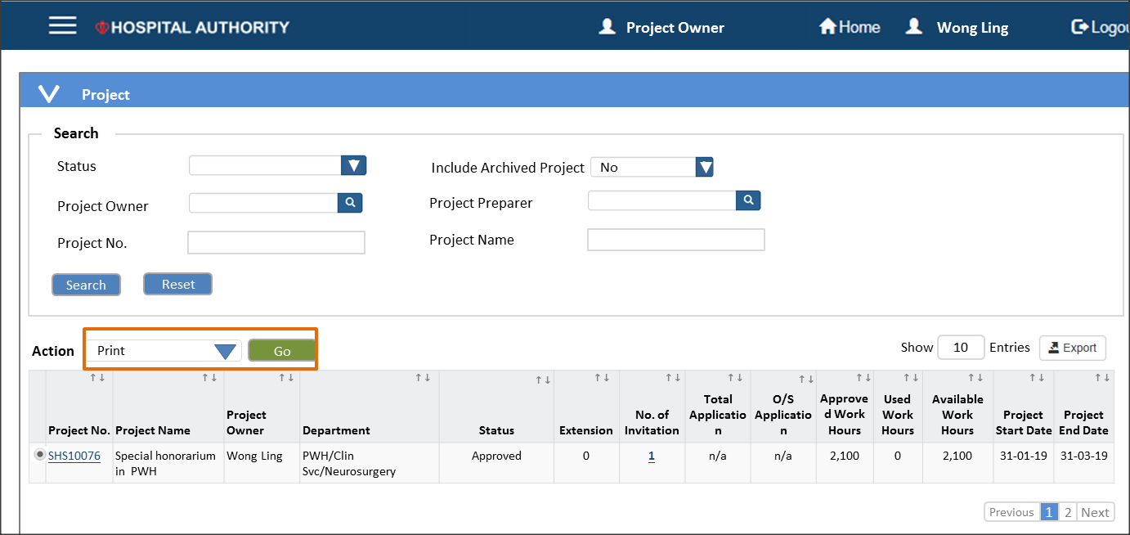

User could choose to include financial impact / approval history in the report.

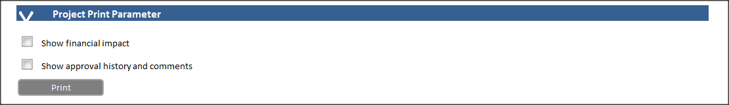

### Project Actions Control

Available actions should depend on the following current user role and project status. A setup table is expected to maintain the user role/project status / action matrix.

## Application and Selection (Phase 2 – out of development scope)

### Process Flow

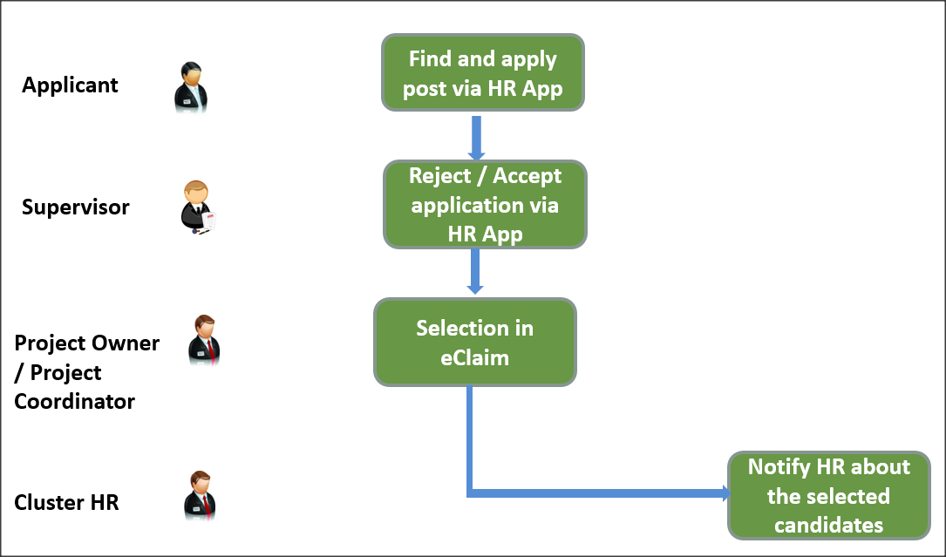

1. Candidate applies SHS via HR App
2. eLeave Supervisor approves SHS application via HR App
3. Cluster HR check eligibility in eClaim
4. Project owner/coordinator select candidate in eClaim

### Apply SHS via HR App

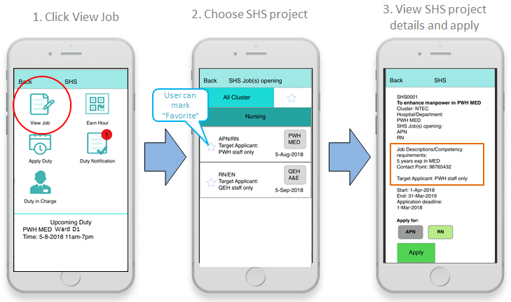

In HR App SHS module, function “View Job” is for applicant to search for interested SHS project.

Staff can view SHS jobs by clusters and staff group. Non-Management Staff can only search for SHS job that opened for his/her staff group. Management staff can view SHS job in different staff group. Staff can view the job rank needed and choose SHS job to check the job detail, then staff can choose multiple job level in each SHS project to apply.

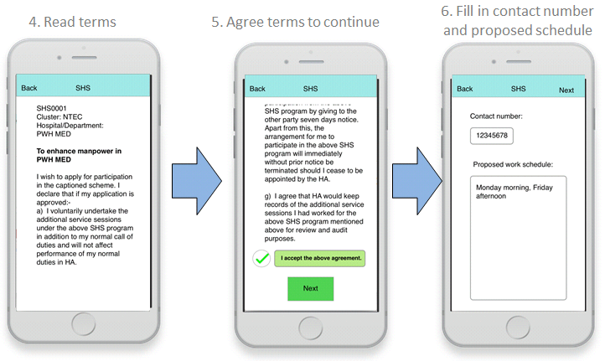

Staff will be required to agree to the Terms and Conditions of the SHS job to start application. Staff needs to provide contact number, propose work schedule. If the staff is working on other SHS project, staff has to provide the project information.

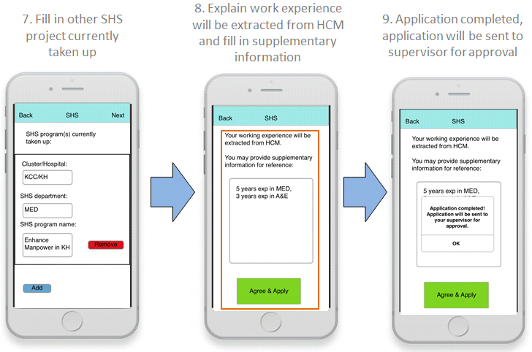

Staff’s working experience will be extracted from HCM, staff need to agree to continue application. Staff may provide additional information for selection, e.g. experience in different specialty.

Application will be sent to applicant’s supervisor for approval.

|  |  |  |  |  |  |
| --- | --- | --- | --- | --- | --- |
| **#** | **Data Element** | **Definition** | **Criticality** | **Input Method** | **Remarks** |
| 1 | Project Id | Source: Project information |  | N/A |  |
| 2 | Project publish Id | Source: Project information after published |  | Number | Unique id for each publish |
| 3 | Contact number | User input | Mandatory | Number |  |
| 4 | Proposed Work schedule | User input |  | Free Text |  |
| 5 | Working SHS project | One to many, link to Working SHS project |  | Free Text | A multiple set of value allow user to add |
| 6. | Additional Information | User input |  | Free Text |  |

Table for Working SHS project:

|  |  |  |  |  |  |
| --- | --- | --- | --- | --- | --- |
| **#** | **Data Element** | **Definition** | **Criticality** | **Input Method** | **Remarks** |
| 1 | Cluster/Hospital | User input | Mandatory | Free text |  |
| 2 | Department | User input | Mandatory | Free text |  |
| 3 | SHS program name | User input | Mandatory | Free text |  |

### Approve SHS Application via HR App

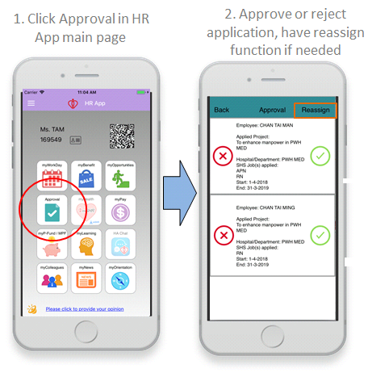

SHS application approval will be combined in HR App “Approval” module. Supervisor can approve or reject SHS application of their subordinates. Supervisor hierarchy will follow the one using in eLeave. Reassign function will also be provided if more than one level approval is needed. (e.g. nurse -> ward manager -> DOM)

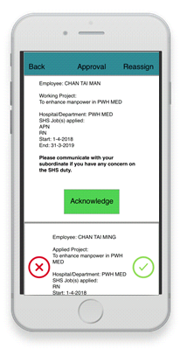

For supervisor change, new supervisor will receive notification for subordinate SHS project for 1 time.. Supervisor can acknowledge the working SHS project. New supervisor can communicate with subordinate if he/she has any concern on the SHS duty.

### Application Selection in eClaim

* + 1. Selection by Project Owner / Project Coordinator

Project owner / coordinator could jump into selection page either by

* Action dropdown
* Click the outstanding application number

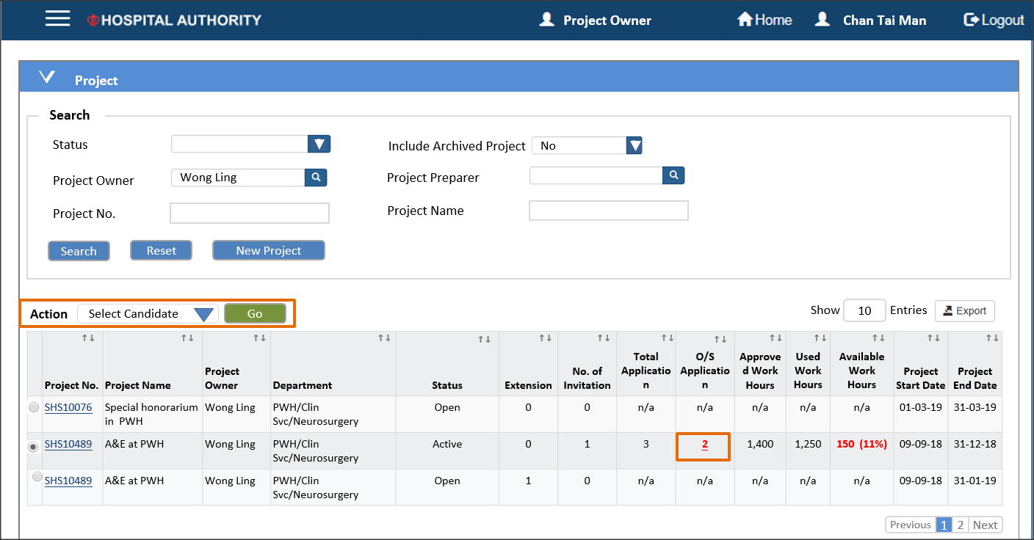

In the select screen, project ownwer and coordinator have different access. Project owner could access all jobs while project coordinator could access the job assigned to her. This screen has two parts.

* Candidate list
* Candidate other information

The data source for candidate list should be

|  |  |  |  |  |  |
| --- | --- | --- | --- | --- | --- |
| **#** | **Data Element** | **Definition** | **Criticality** | **Input Method** | **Remarks** |
| 1. 1 | Application Date |  | n/a | n/a | Information from HR App |
|  | Emp. No. |  | n/a | n/a | Information from HR App |
|  | Employee Name |  | n/a | n/a | Information from HR App and HCM |
|  | Department |  | n/a | n/a | Information from HR App and HCM |
|  | Date to Present Rank |  | n/a | n/a | Information from HR App and HCM |
|  | Rank |  | n/a | n/a | Information from HR App and HCM |
|  | SHS Job Applied |  | n/a | n/a | Information from HR App |
|  | Recommended? |  | Optional | List of Values | If no value, it’s an outstanding application |
|  | Remark |  | Optional | Free text |  |

The data source for candidate other information should be

|  |  |  |  |  |  |
| --- | --- | --- | --- | --- | --- |
| **#** | **Data Element** | **Definition** | **Criticality** | **Input Method** | **Remarks** |
| 1. 1 | Emp. No. |  | n/a | n/a | Information from HR App |
|  | Chinese Name |  | n/a | n/a | Information from HR App and HCM |
|  | Email |  | n/a | n/a | Information from HR App and HCM |
|  | Contact Number |  | n/a | n/a | Information from HR App |
|  | Proposed Work Schedule |  | n/a | n/a | Information from HR App |
|  | Supplementary Information |  | n/a | n/a | Information from HR App |
|  | SHS Currently Take Up |  | n/a | n/a | Information from HR App |

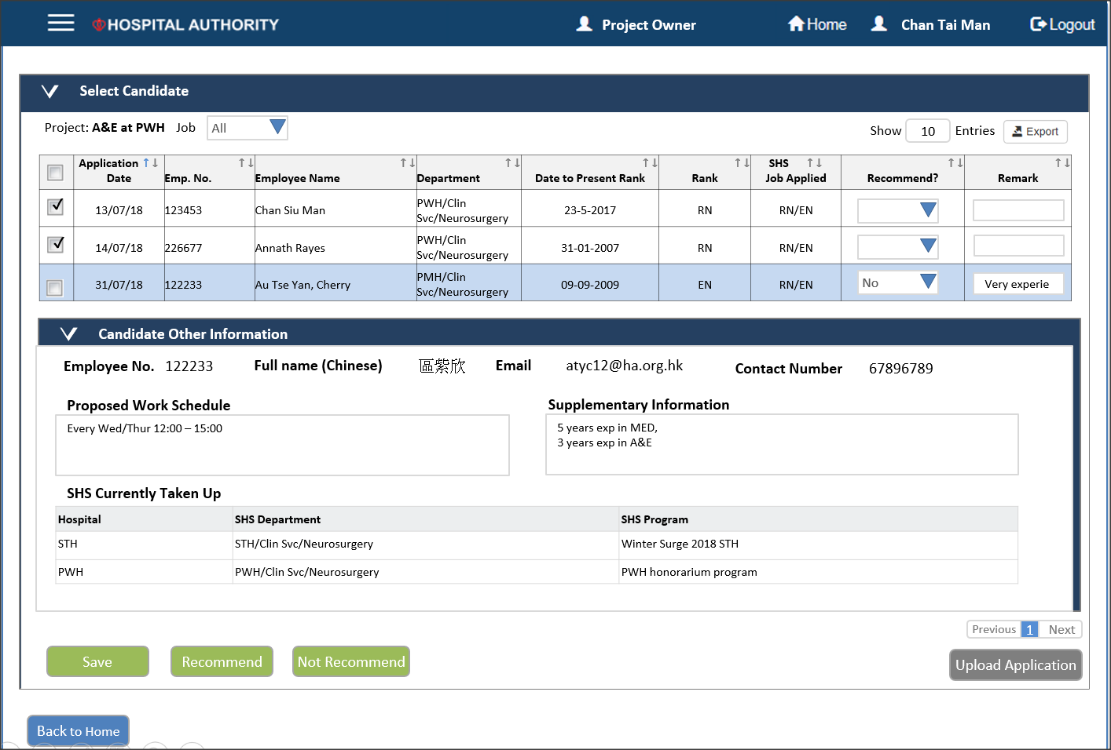

* + 1. Upload application by HR User/Project Owner/Project Coordinator

System allows users to upload application in excel format

1. User find the target project and choose “Upload Candidate” in the action list (or click “Upload Application” button in “Select Candidate”

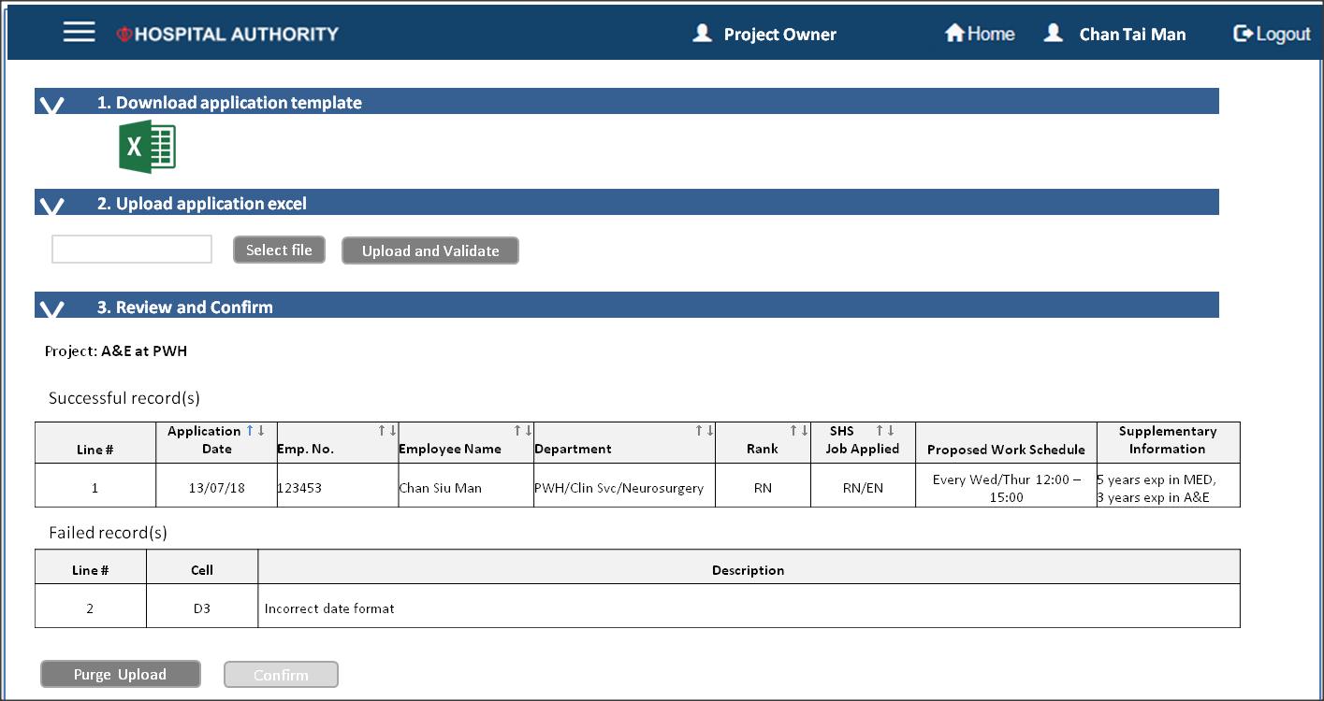

1. Step 1 – user download the template by clicked
2. Step 2 – input the application into the excel template. Click “Select” button or open the file browser and click “Upload and Validate” button after chose the file.
3. Step 3 – show validate results, show successful and failed records. If no error found, user could click confirm to import.

## Duty Schedule and Attendance (Phase 2 – out of development scope)

### Process Flow

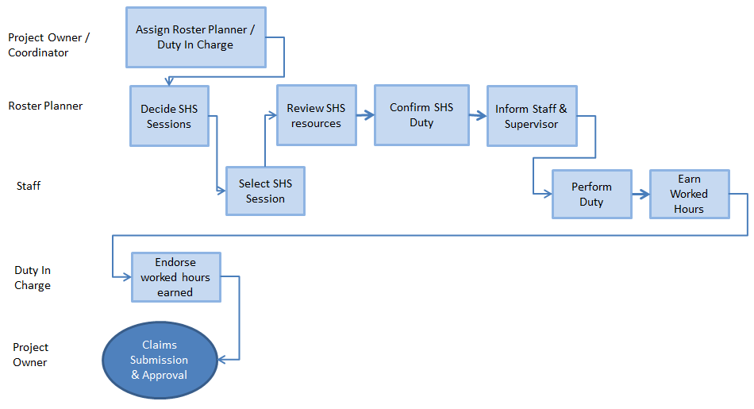

1. Project Owner / Coordinator to assign Roster Planner and Duty in Charge to manage the duty schedule and attendance respectively. When SRS department is inputted in Project initiation, Roster Planner and Duty in Charge role access right would be imported.
2. Roster Planner can access the schedule of assigned location and defines the SHS sessions.
3. Staffs raise SHS session requests.
4. Roster Planner reviews staff requests and available SHS resources. If the staff request is not suitable or too much request, then roster planner can reject the inappropriate requests.
5. After complete duty schedule, Roster Planner can confirm and publish and inform the staffs. Their supervisors also are informed in the first time of attending SHS.
6. Attendances are required the confirmation both of Duty I/C and staff in the time in and out.
7. If the attendance detail is not precise enough, Duty I/C can provide for further update.

### Overall

The Status of duties are changed as following.

. 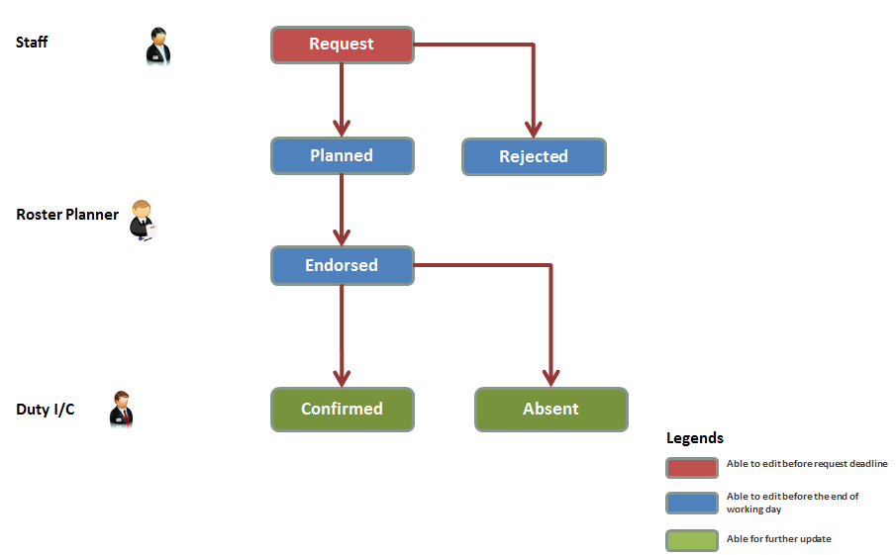

|  |  |  |  |  |
| --- | --- | --- | --- | --- |
| **Status** | **Process** | **Step** | **System Role** | **Remarks** |
| Request | Duty Schedule | Raise Request | Staff | Not available change after deadline |
| Rejected | Duty Schedule | Reject Request | Roster Planner |  |
| Planned | Duty Schedule | Plan Duty | Roster Planner |  |
| Endorsed | Duty Schedule | Publish Duty | Roster Planner | Sent Acknowledgement to staffs |
| Confirmed | Attendance | Confirm Attendance | Duty I/C and Staff | Able for further update |
| Absent | Attendance | Mark Absent | Duty I/C | Able for further update |

### User Administration

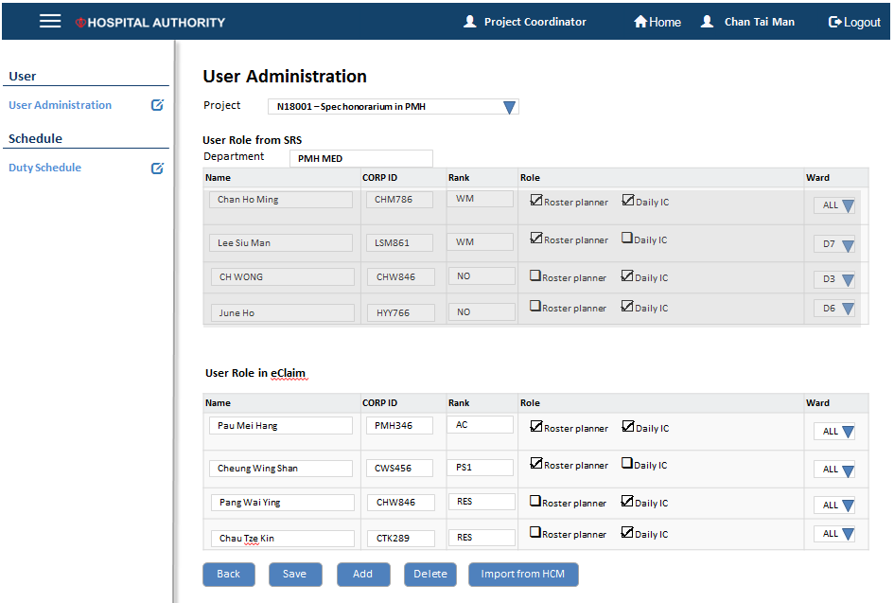

1. Available project s could be selected.
2. Project Owner / Coordinator to assign Roster Planner and Duty in Charge and set the accessible location.
3. When SRS department is inputted in Project initiation, Roster Planner and Duty in Charge role access right would be imported.
4. If the project do not linked with SRS, staff list could be get from HCM.

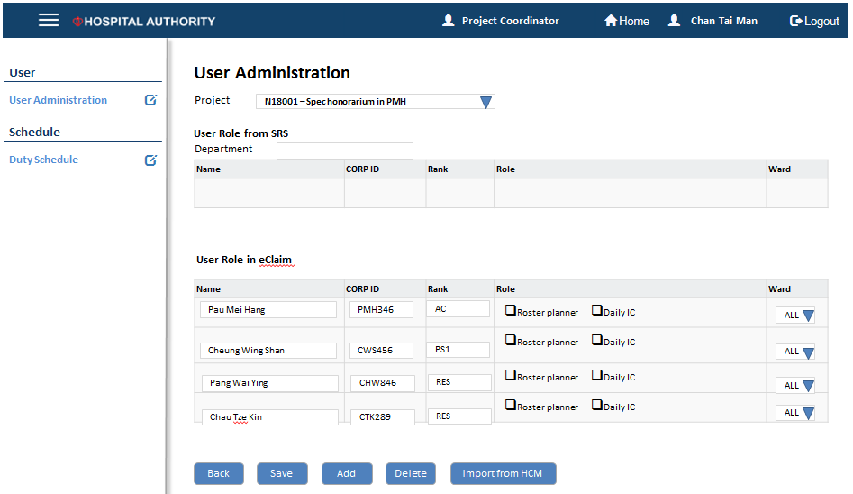

### Define Session

1. Session could be defined in Duty Schedule.

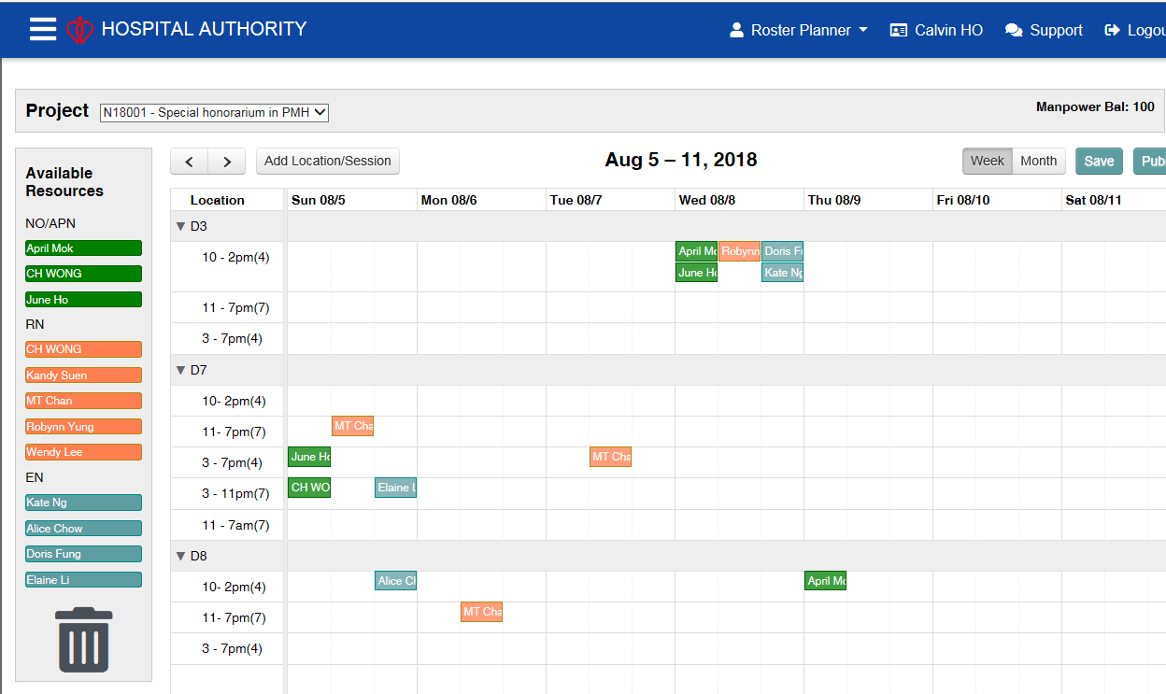

1. Available project can be selected by the drop down menu at the top. The work hour balance shown at top right hand corner. Reminder would show when work hour balance is low.

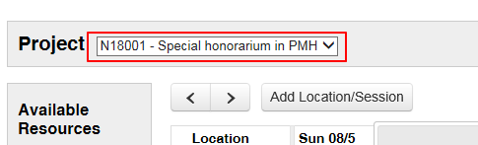

1. Roster planner could create SHS session by “Add Location/Session” Button. The session detail could be defined in the form. The default location list is come from SRS, which can be modified. The work hour is calculated by session time and meal work.



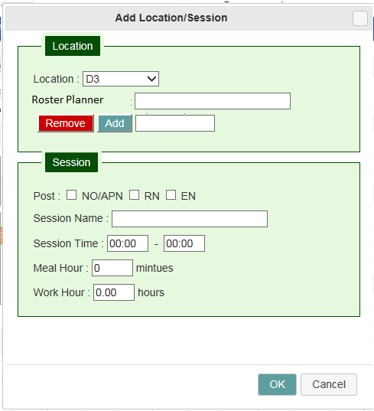

1. If the session crossed midnight, then the work hour would be split into two potions. The 2nd day work hour is calculated by session time, meal work and 1st day work hour.

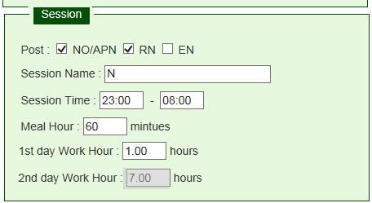

### Apply Duty for SHS timeslot

* + 1. For Web

Applicable rank of staff will be listed at the left panel. Staff will drag request to the target session. Staff only can apply one time for each session.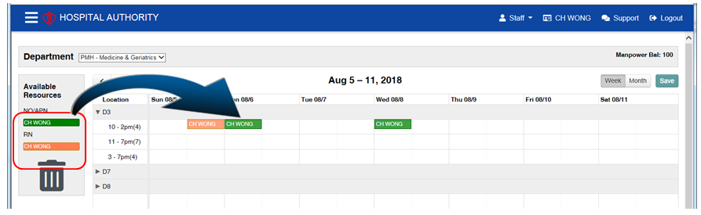

* + 1. For HR App:

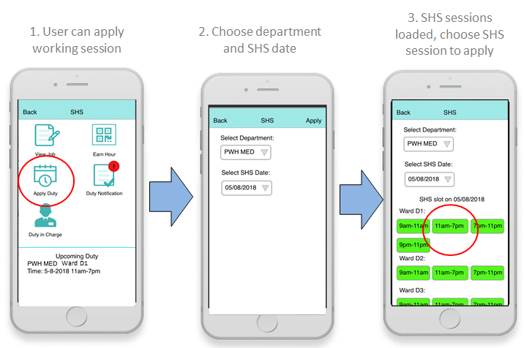

After duty planner published the working session, HR App would receive notifications. Staff can click “Apply Duty” in SHS module to apply for working session. Staff first chooses the hospital/department and SHS date, a list of available working session will be shown. Staff can choose the working session to check session detail.

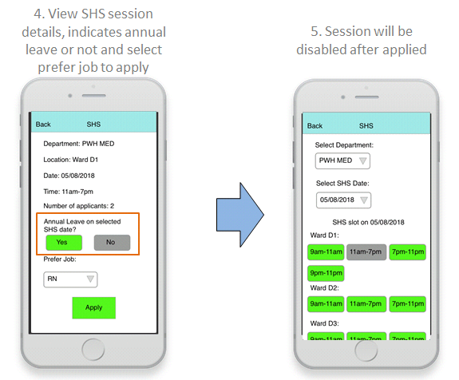

Staff can check the working session’s detail such as Location, Date, Time, Number of staff already selected this session. Then staff MUST state if the SHS date is annual leave or not, but this option will not block the application if staff choose “NO”. At the end staff choose prefer job to apply for, staff can only select one prefer job per working session. The applied working session will be disabled.

### Schedule

Assign SHS

Selected employees in application will be listed at the left panel. Schedule planner could drag the employee to the target session.

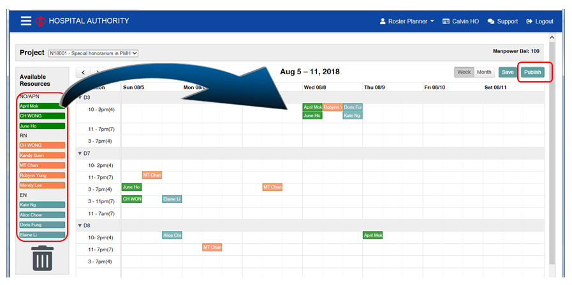

For Web

Selected employees in application will be listed at the left panel. Schedule planner could drag the employee to the target session.

Session detail could be shown by click the assigned session. The session time and meal hour could be modified.

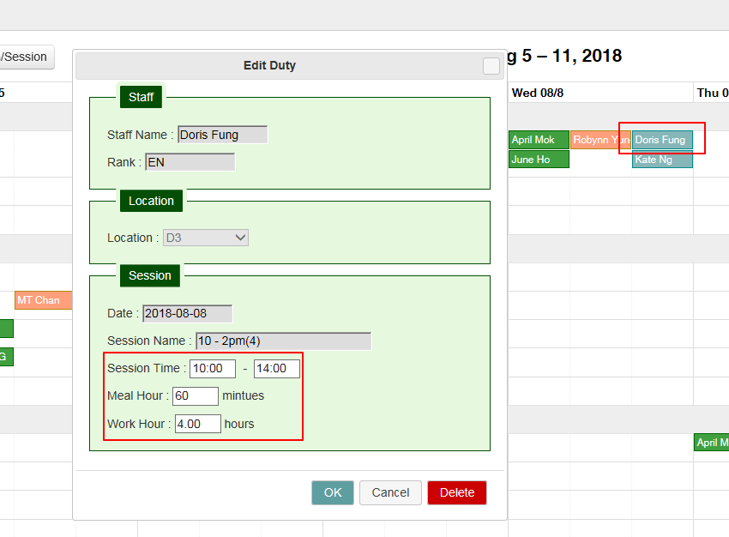

When the employee is selected, her SRS duty and leave would be shown at header.

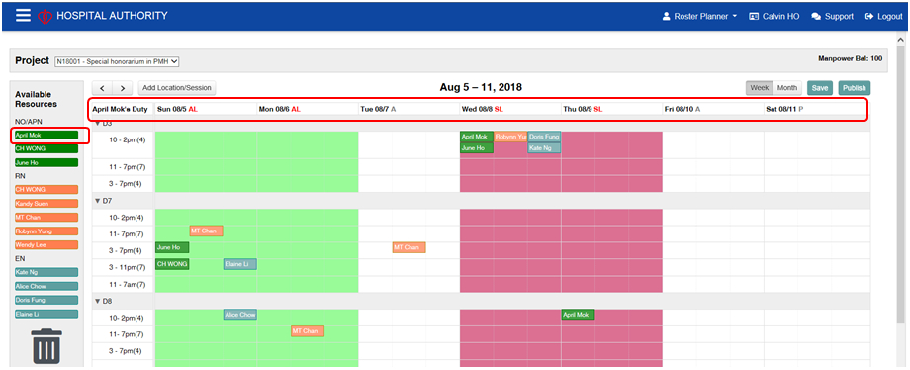

### Receive notification after being selected for SHS Duty

* + 1. In Web: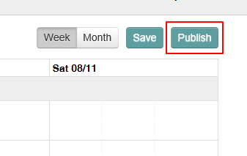

1. After complete the schedule, roster planner can publish the SHS by click the publish button.
2. Confirmation form to ask schedule planner to confirm the publish period

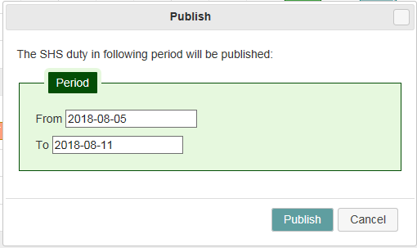

1. Tick would be shown when acknowledgement is received by staff.



* + 1. In HR App:

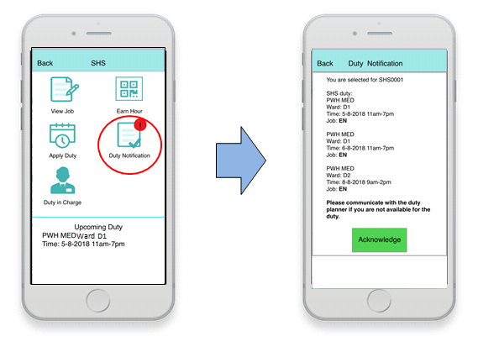

After duty planner planned the weekly SHS duty, staff will receive notification for SHS duty. Staff can go into SHS module and click “Duty Notification”. The SHS duty assigned for the staff will be shown and staff then acknowledges the duty. Staff should communicate with the duty planner if there is any problem on the duty.

### Staff attend duty, scan QR code of Duty In Charge to clock in/out

There are 3 approaches to confirm attendance

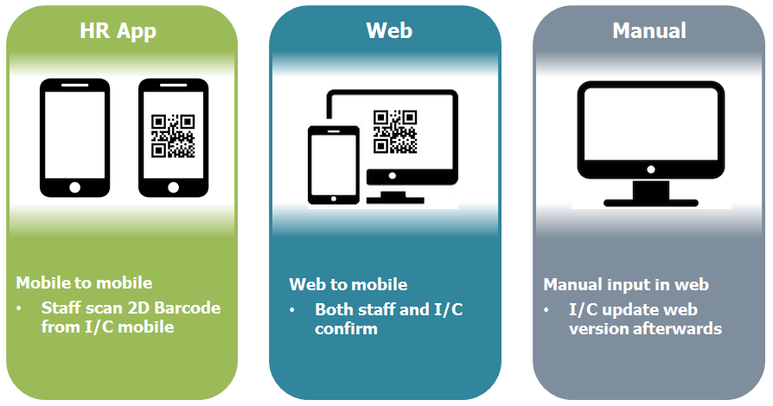

Mobile to mobile

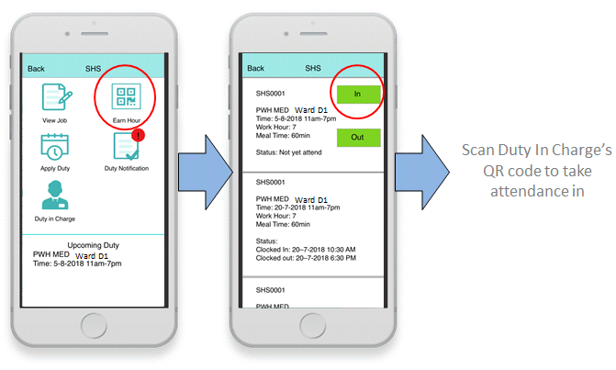

When staff attends SHS duty, staff clicks “Earn Hour” to view working session. Staff can click “In” to scan Duty In Charge’s QR code to take attendance in.

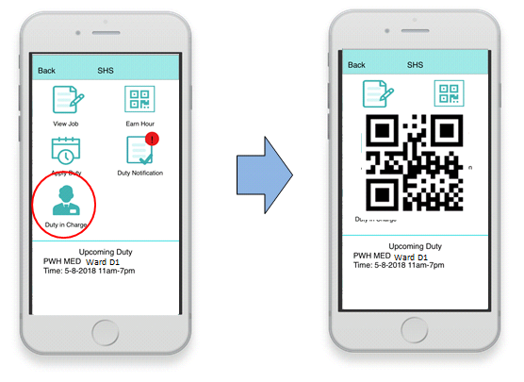

Then Duty In Charge(clock in) open HR App SHS module, click “Duty In Charge” function. A QR code will be shown for colleague to scan.

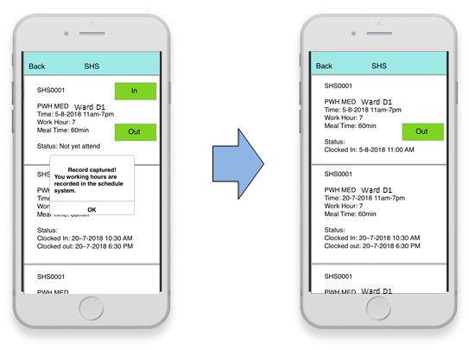

Attendance in has been taken and clock in time will be recorded.

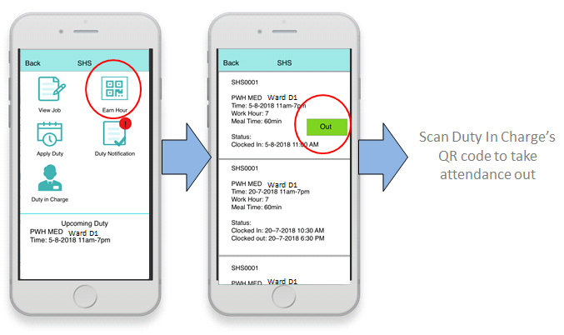

When staff finished SHS duty, staff clicks “Earn Hour” to view working session. Staff can click “Out” to scan Duty In Charge’s QR code to take attendance out.

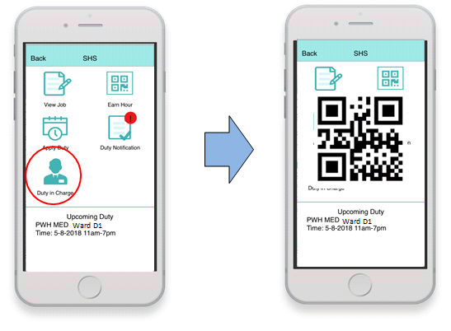

Then Duty In Charge(clock out) open HR App SHS module, click “Duty In Charge” function. A QR code will be shown for colleague to scan.

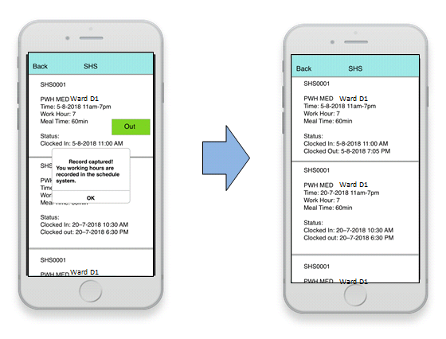

Attendance out has been taken and clock out time will be recorded.

Web to moblie

1. Duty I/C do not use HA App, the QR code can be provided by the web.
2. The available projects of Duty in charge are shown at top.
3. When project is selected, the endorsed duty from duty schedule of current day would be list out.
4. The date can be changed to get the past attendance record.
5. The QR code in web has same function to the mobile, which can be print. Staff can earns SHS by scan the QR code in web.
6. Before scanning QR code, duty I/C and staff need to ensure the SHS Details.
7. After QR code is scanned by staffs. Scanning time and the CORP ID of duty I/C and staff would be marked in the confirm columns.
8. The SHS details would locked after the confirmation of time in and out
9. If the duty was not attended by staff, Duty I/C can mark absent.

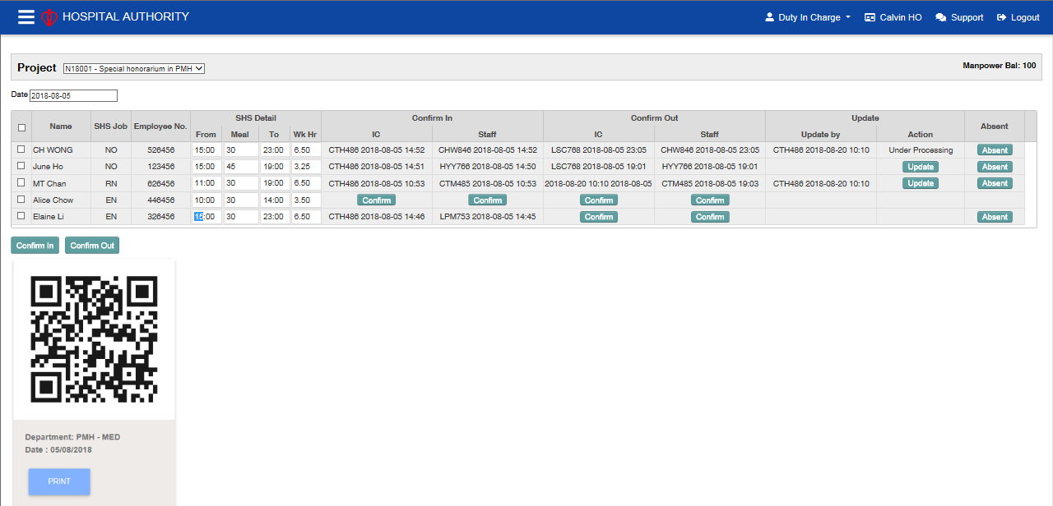

Manual input in Web

1. If Duty I/C and staffs do not use HA App, attendance can be confirmed by Duty I/C on the web.
2. Duty I/C can do batch confirm by ticking records.
3. The checkbox at the header provide selecting all rows function.

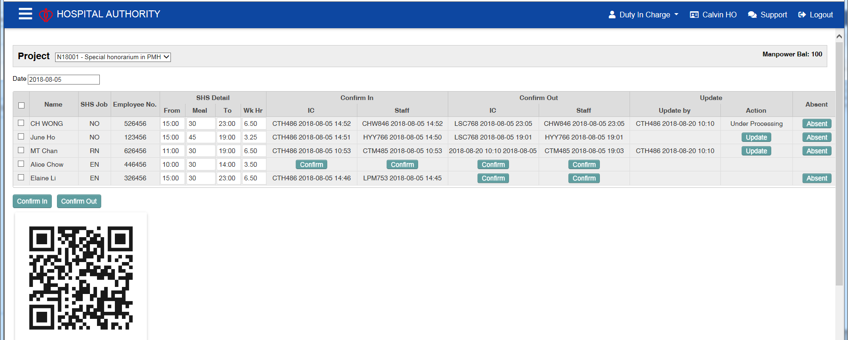

c

c

### Further Update

1. Duty I/C can do further update after confirm attendance.
2. Confirmed records are locked.
3. Attendance can be unlocked by click the update button.
4. A dialog would pop-up for entry remark.
5. After further update. Update time and the CORP ID of Duty IC would be marked in the update by column.

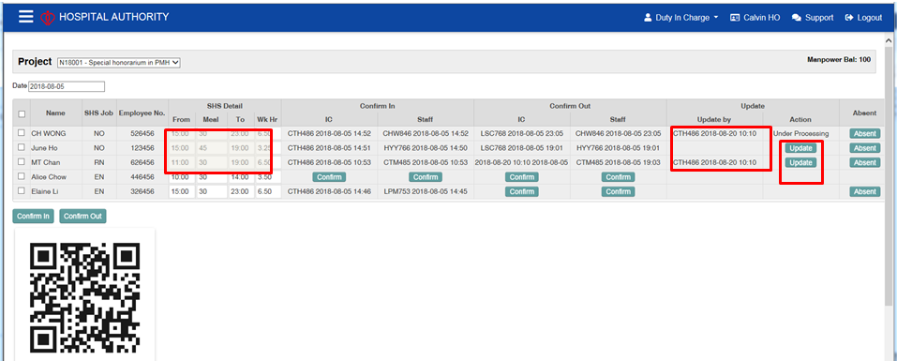

## Claim Submission (Phase 1)

### Process Flow

1. Claim Preparer to prepare outstanding claim record(s) up to specified pay month and submit the valid record(s) to Claim Approver for approval while the invalid claim record(s) which require to be clarified should be on-hold. Claim Preparer should read disclaimer and then send notification to Claim Approver for further action. Change of claim record details (e.g. employee no., job, work hours, etc) is not allowed.
2. Claim Approver to approve claim record(s) in read only mode upon notification is received. When there is a need to withhold the claim, Claim Approver can return for correction. As such, Claim Preparer can unselect the invalid claim record(s) and re-submit the valid claim records to Claim Approver for approval again. When all claim records are verified okay, Claim Approver to approve the claim. Claim Approver should read disclaimer and then send notification to Payroll Officer for further action.
3. Cluster Payroll Officer to review approved claim record(s) upon notification is received. Payroll Officer is allowed to override defaulted Costing for each claim record propagated from Project Initiation. When all claim records are reviewed okay, Payroll Officer to submit the reviewed claim record(s) for Payroll Manager’s validate and transfer Batch Element Entries (BEE) into HCM while the problem record(s) which require to be clarified should be unselected before submitting to Payroll Manager for validate and transfer BEE process.
4. Cluster Payroll Manager to validate and transfer BEE batch into HCM upon notification is received. When there is a need to take out claim record(s) from being processed in HCM, Payroll Manager can return for correction. As such, Payroll Officer can unselect problem record(s) and re-submit valid claim records to Payroll Manager for validate and transfer BEE again. When all claim records are verified okay, Payroll Manager to validate and transfer the BEE batch. Payroll Manager should check status of submitted BEE batch and follow up with problem record, if any.

### Overall

Landing page is required to show status of claim records during the Claim submission process which include but not limited to the following status.

|  |  |  |  |  |
| --- | --- | --- | --- | --- |
| **Status** | **Process** | **Step** | **System Role** | **Remarks** |
| Confirmed | Attendance | N/A | Duty I/C | The required status before Claim Preparer is eligible to prepare claim records. |
| Selected | Claim Submission | Prepare Claim | Claim Preparer | If not selected, record still in ‘Confirmed’ status. |
| Approved | Claim Submission | Approve Claim | Claim Approver | If not selected, record still in ‘Confirmed’ status i.e. Transaction is pending for approval. |
| Reviewed | Claim Submission | Review Claim | Payroll Officer | If not selected, record still in ‘Approved’ status i.e. Transaction is pending for transfer to HCM. |
| Partial transferred | Claim Submission | Validate & Transfer BEE | Payroll Manager | If not selected, record still in ‘Approved’ status i.e. Transaction is pending for transfer to HCM. |
| Transferred | Claim Submission | Validate & Transfer BEE | Payroll Manager | All ‘Approved’ record must be selected and transferred in HCM. |

**Sample Landing Page (Status of claim records)**

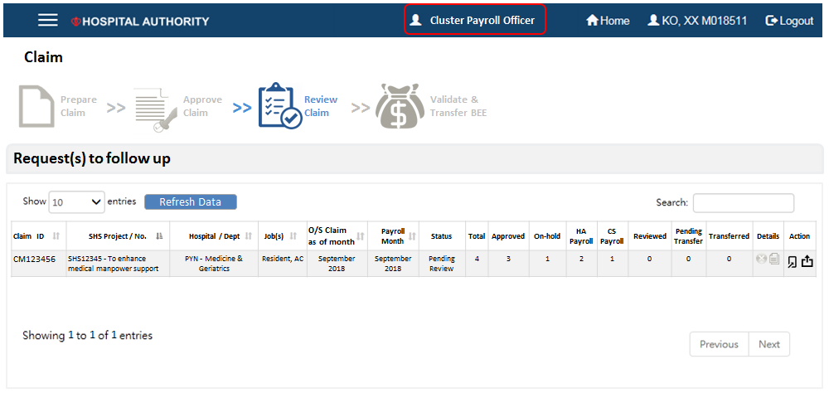

Corresponding active step during the Claim submission process will be shown as graphical user interface on top but below the topmost tool bar while the graphical user interface should be dimmable when the step is inactive.

The menu on left should be hidden or displayed when clicking on hamburger button at top left corner.

**Sample Layout for claim submission steps to be shown on the top and the left**

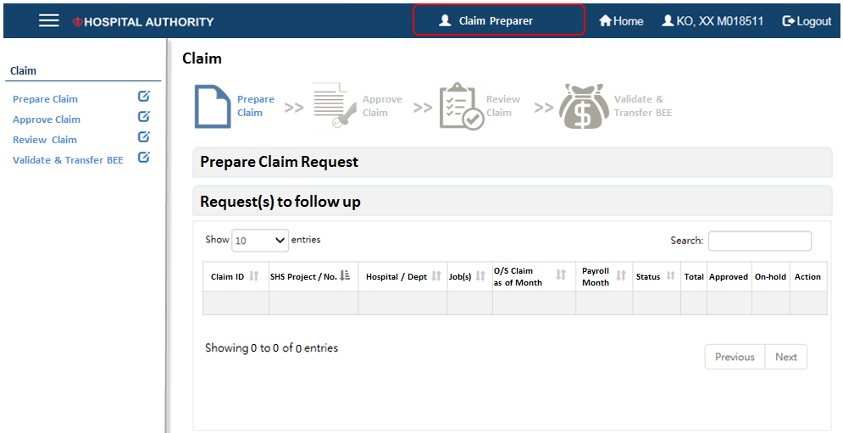

### Prepare Claim

Duty in charge should confirm attendance records in Attendance module on cutoff date (e.g. Day 20th of every month) such that Claim preparer is able to prepare claim records for payment in HCM.

When the status of attendance record updated as ‘Confirmed’ in Attendance module, it is eligible to be converted into claim record.

*Note: Attendance records are splitting into duty sessions (i.e. multiple sessions per day) while claim records are aggregated by day.*

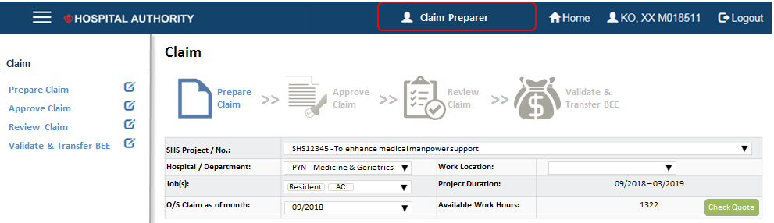

Claim Preparer is able to select parameters but not limited to the below in order to prepare outstanding claim records including adjustment of work hour of paid claim record up to specified month of which the records are propagated from Attendance module which include on-hold (unselected) claim records by Claim Preparer.

|  |  |
| --- | --- |
| **Parameters** | **Remarks** |
| SHS Project | Propagated from Project Initiation |
| Hospital / Department | Same as above |
| Work Location | Propagated from Duty Schedule |
| Job(s) | Propagated from Project Initiation |
| O/S Claim as of month | List of values from system go-live date to current system date.  Format as MM/CCYY; default from System Date |
| Project Duration | Propagated from Project Initiation |
| Available Work Hours | Calculate and maintain from Project Initiation (i.e. approved work hours) and Duty Schedule (i.e. planned work hours from scheduled duty sessions).  Formula:  Available Work Hours = Approved Work Hours – Used Work Hours  (where Used Work Hours = planned work hours from scheduled duty sessions + realized work hour) |

Claim Preparer to review outstanding claim records and able to select or unselect claim records before submission to Claim Approver. When Claim Preparer click ‘Submit’ button, notification email template is then pop-up for reviewing. Pre-defined content in notification is not editable. Recipient list is defaulted from list of Claim Approver pre-defined by Project Owner. Claim Preparer can add more recipients on the CC list and input supplement content when required. After clicking ‘Send’ button, Claim Preparer is required to read disclaimer before submitting claim records to Claim Approver for approval.

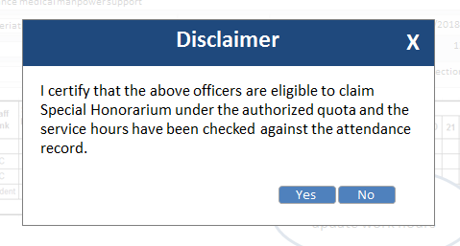

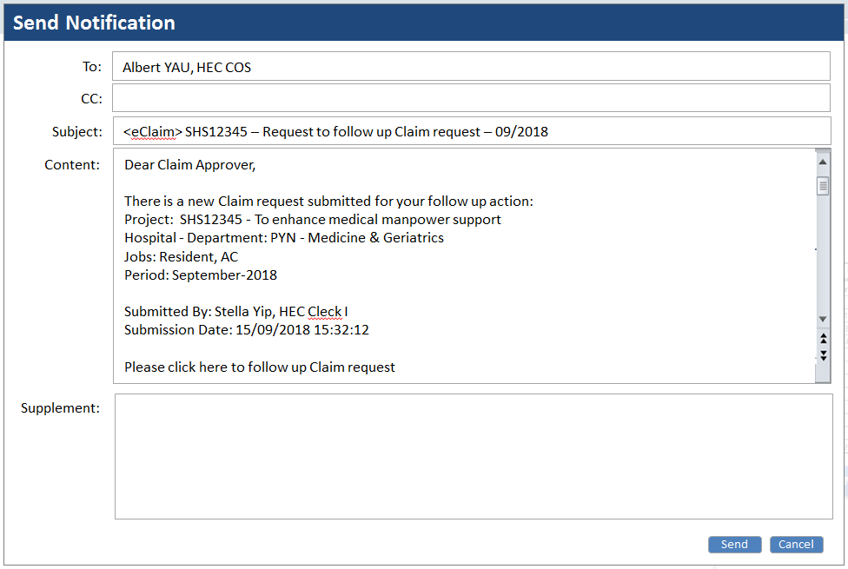

When Claim Preparer clicks ‘Save’ button, the selected / unselected claim records are kept in system for further action while clicking ‘Quit’ button it will return to landing page without record save.

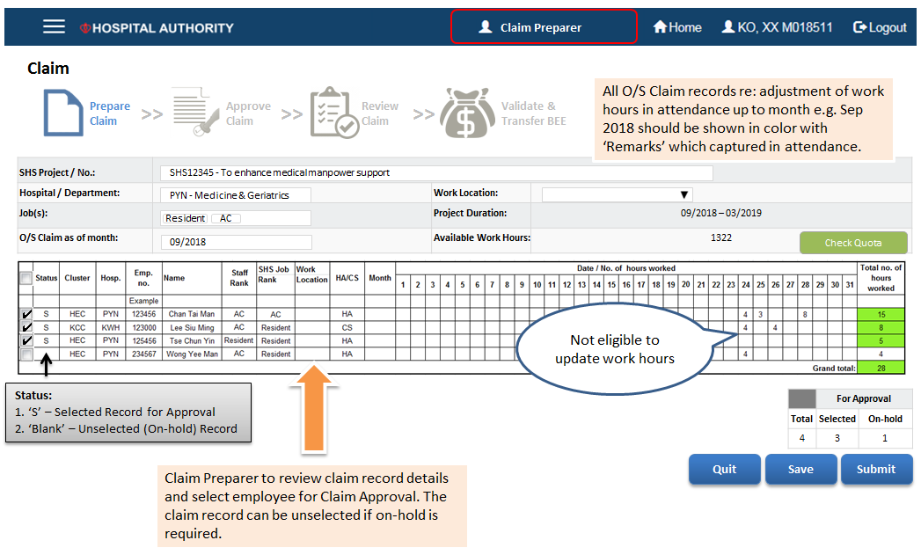

**Check Quota function button**

This function allows user to check available work hours by project by job(s) defined in Project Initiation. Meanwhile, user editable threshold (e.g. 80% of approved work hours) should be predefined in system for quota monitoring.

Available Work Hours = Approved Work Hours – Used Work Hours (where Used Work Hours = planned work hours from scheduled duty sessions + realized work hour)

*Note: Planned work hours will be transformed into realized work hours when attendance records are confirmed by Duty I/C.*

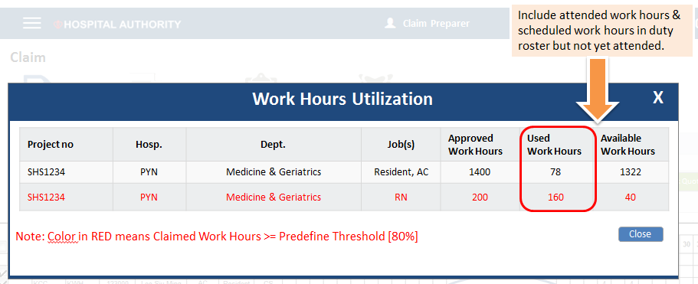

### Approve Claim

Claim Approver to verify the claim records upon receiving notification submitted by Claim Preparer.

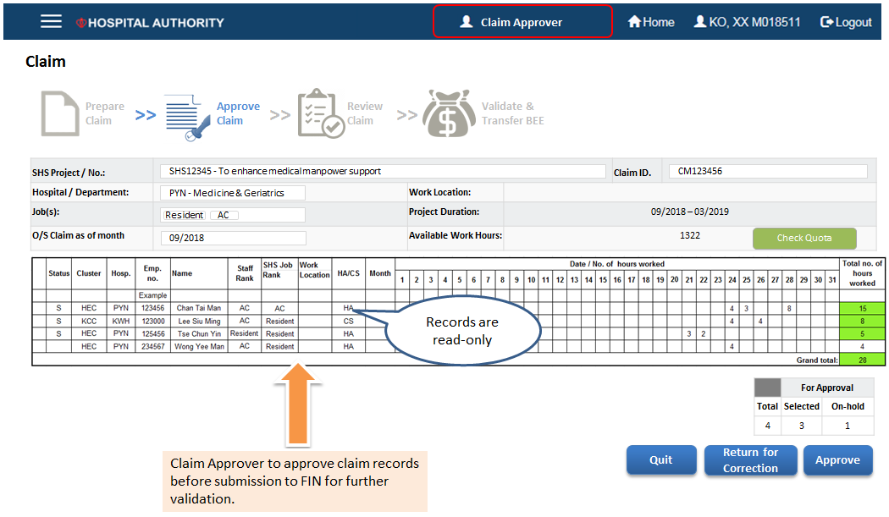

When Claim Approver click ‘Approve’ button, notification email template is then pop-up for reviewing. Pre-defined content in notification is not editable. Recipient list is defaulted from list of Clusters Payroll Officer pre-defined by Cluster users. Claim Approver can add more recipients on the CC list and input supplement content when required. After clicking ‘Send’ button, Claim Approver is required to read disclaimer before submitting to Clusters Payroll Officer for reviewing the claim records.

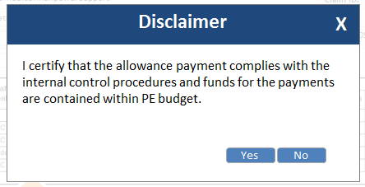

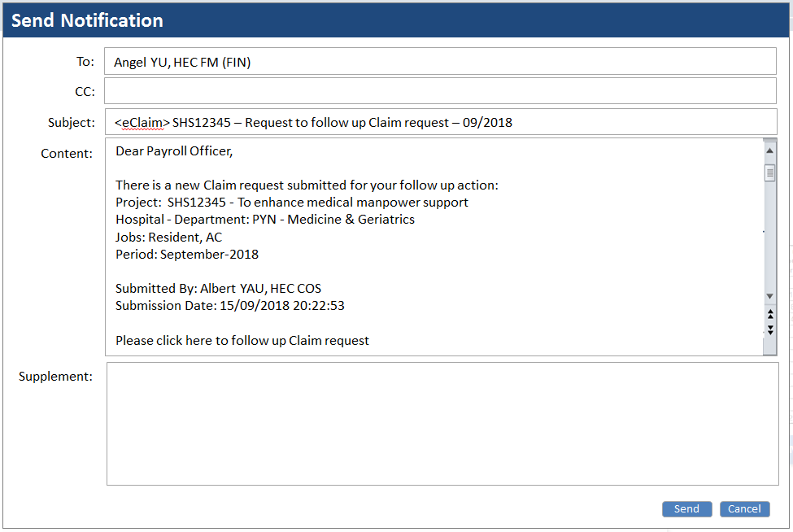

When Claim Approver click ‘Return for correction’ button, notification email template is then pop-up for reviewing. Pre-defined content in notification is not editable. Recipient list is defaulted from list of Claim Preparer pre-defined by Project Owner. Claim Approver can add more recipients on the CC list and input supplement content when required. After clicking ‘Send’ button, notification will be sent to Claim Preparer.

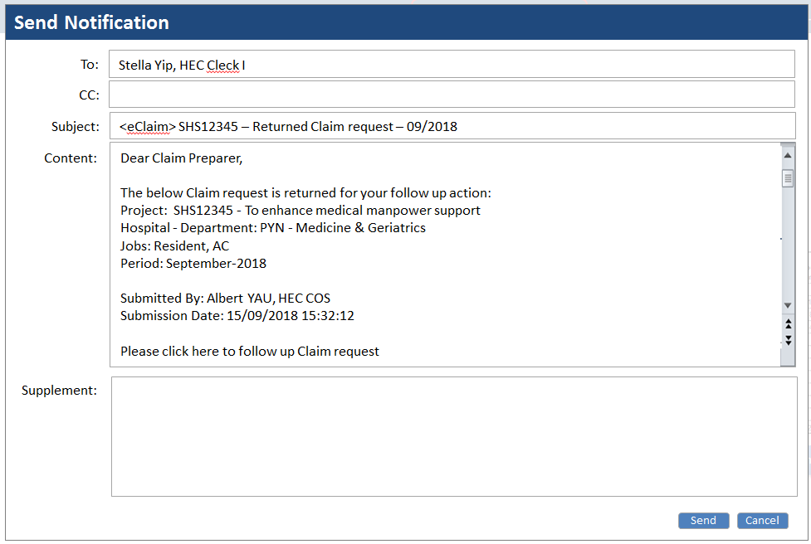

### Review Claim

Clusters Payroll Officer to review claim records upon receiving notification submitted by Claim Approver. Only those claim records belong to HA Payroll are eligible for Payroll Officer’s reviewing.

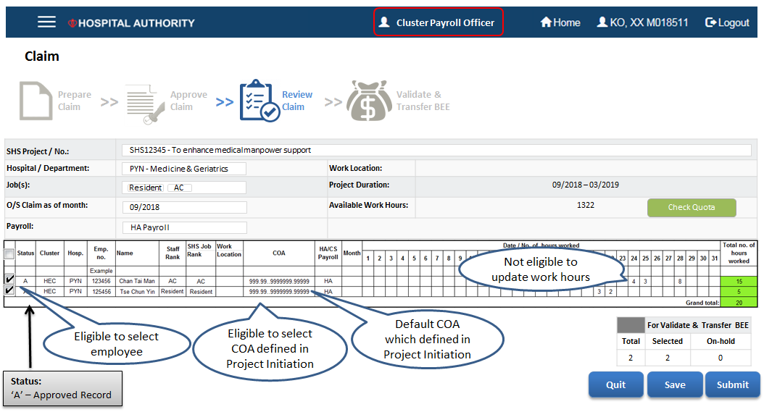

Cluster Payroll Officer is able to select or unselect ‘approved’ claim records before submission to Cluster Payroll Manager. Also, Cluster Payroll Officer is allowed to manual override the defaulted costing of each claim record due to retrospective change of costing after Project Initiation process. When Cluster Payroll Officer click ‘Submit’ button, notification email template is then pop-up for reviewing. Pre-defined content in notification is not editable. Recipient list is defaulted from list of Cluster Payroll Manager pre-defined by Cluster users. Cluster Payroll Officer can add more recipients on the CC list and input supplement content when required. Notification will be sent to Cluster Payroll Manager after clicking ‘Send’ button by Cluster Payroll Officer. System needs to provide functionality for Cluster Payroll Officer to override the payment rate of SHS by project. (note: this data field is not yet added in the prototype screen)

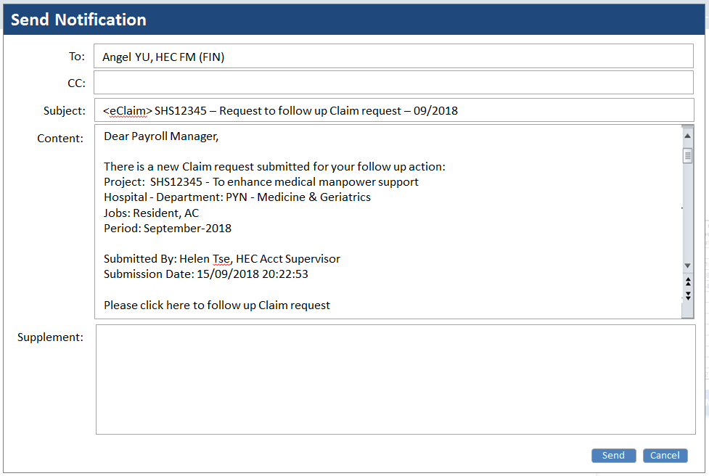

When Cluster Payroll Officer clicks ‘Save’ button, the selected/unselected ‘approved’ claim records are kept in system for further action while clicking ‘Quit’ button it will return to landing page without record save.

For those unselected ‘approved’ claim records, Cluster Payroll Officer is able to select and submit to Cluster Payroll Manager after the previous submission.

**Note for Phase 1: Since the Attendance module is not yet available in Phase 1, Bulk Upload function is required for user to upload the attendance / claim records (in predefined format) for subsequent review, approval and payment processes.**

### Validate and Transfer Batch Element Entries

Cluster Payroll Manager to validate and transfer Batch Element Entries (BEE) in HCM upon receiving notification submitted by Cluster Payroll Officer.

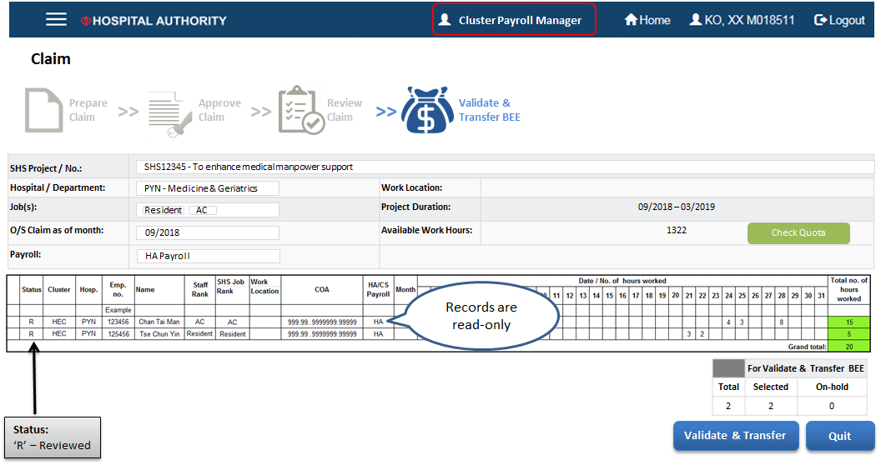

When Cluster Payroll Manager click ‘Validate & Transfer’ button, element entry(ies) per day is/are generated according to converted claim records from attendance records. Regarding one to one mapping of attendance against element entry record OR claim against element entry record subject to technical design.

|  |  |  |  |
| --- | --- | --- | --- |
| **Scenario** | **Attendance record** | **Claim record** | **Element entry record** |
| Same Job in 2 sessions | Rec#1: ‘Emp A’ ‘30 Aug 2018’ ‘10:00 – 14:00’ ‘4 hours’ ‘AC’  Rec#2: ‘Emp A’ ‘30 Aug 2018’’18:00 – 22:00’ ‘4 hours’ ‘AC’ | Rec#1 ‘Emp A’ ‘30 Aug 2018’ ‘AC’ ‘8 hours’ | Rec#1 ‘Emp A’ ‘30 Aug 2018’ ‘AC’ ‘8 hours’ |
| Different Jobs in 2 sessions | Rec#1: ‘Emp A’ ‘30 Aug 2018’‘10:00 – 14:00’ ‘4 hours’ ‘AC’  Rec#2 ‘Emp A’ ‘30 Aug 2018’’18:00 – 22:00’ ‘4 hours’ ‘Resident’ | Rec#1: ‘Emp A’ ‘30 Aug 2018’‘10:00 – 14:00’ ‘4 hours’ ‘AC’  Rec#2 ‘Emp A’ ‘30 Aug 2018’’18:00 – 22:00’ ‘4 hours’ ‘Resident’ | Rec#1: ‘Emp A’ ‘30 Aug 2018’‘10:00 – 14:00’ ‘4 hours’ ‘AC’  Rec#2 ‘Emp A’ ‘30 Aug 2018’’18:00 – 22:00’ ‘4 hours’ ‘Resident’ |
| Same Jobs in 1 session which across mid-night e.g. 30/8 (22:00 – 02:00) | Rec#1: ‘Emp A’ ‘30 Aug 2018’ ‘22:00 – 00:00’ ‘2 hours’ ‘AC’  Rec#2: ‘Emp A’ ‘31 Aug 2018’ ‘00:00 – 02:00’ ‘2 hours’ ‘AC’ | Rec#1: ‘Emp A’ ‘30 Aug 2018’ ‘22:00 – 00:00’ ‘2 hours’ ‘AC’  Rec#2: ‘Emp A’ ‘31 Aug 2018’ ‘00:00 – 02:00’ ‘2 hours’ ‘AC’ | Rec#1: ‘Emp A’ ‘30 Aug 2018’ ‘22:00 – 00:00’ ‘2 hours’ ‘AC’  Rec#2: ‘Emp A’ ‘31 Aug 2018’ ‘00:00 – 02:00’ ‘2 hours’ ‘AC’ |

### Other considerations

System should able to handle regeneration of claim records due to adjustment of attendance records. This would be treated as outstanding claim which allows Claim Preparer to retrieve such records in the next specified month for retrospective adjustment.

System should allow Payroll Officer/Manager to view status of each element entry processed in HCM and able to regenerate entries for error out cases returned from HCM.

System should allow Payroll Officer/Manager to override defaulted pay rate (i.e. Entry value ‘Reason’ in SHS element entry in HCM) for each claim records which are already paid in HCM in order to handle policy change during active project period.

Support export function to download all claim records i.e. CS Payroll, HA Payroll or both payrolls.

## System Administration (Phase 1)

### HO Administrator

* + 1. Landing Page

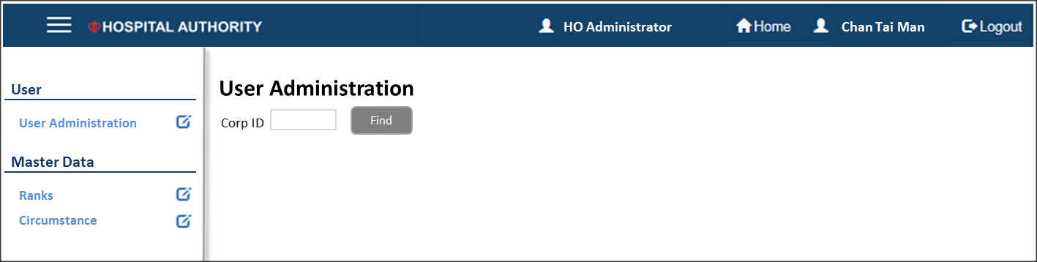

* + 1. User Administration

1. Search user by Corp ID and click “Find” button. All personal information is retrieved from HCM.

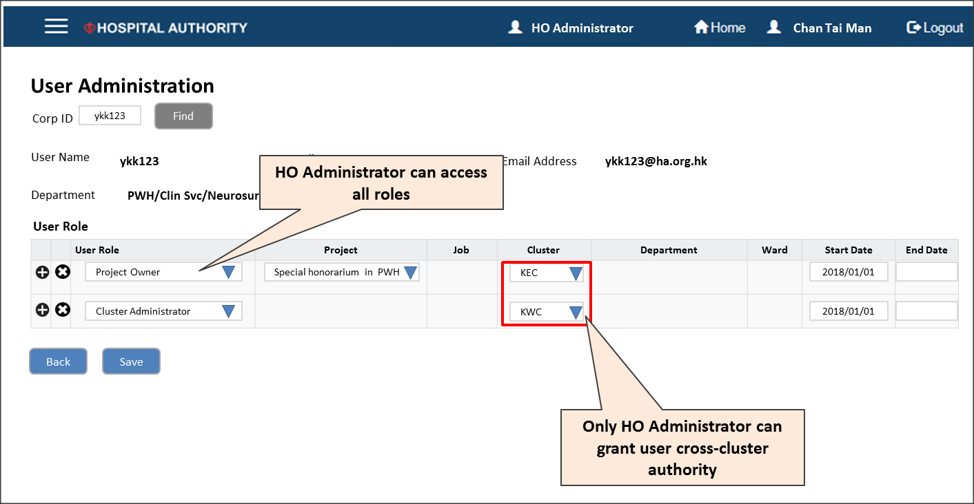

1. HO Administrator could access all roles in eClaim system.
   * 1. Master Data

Rank (From HCM directly)

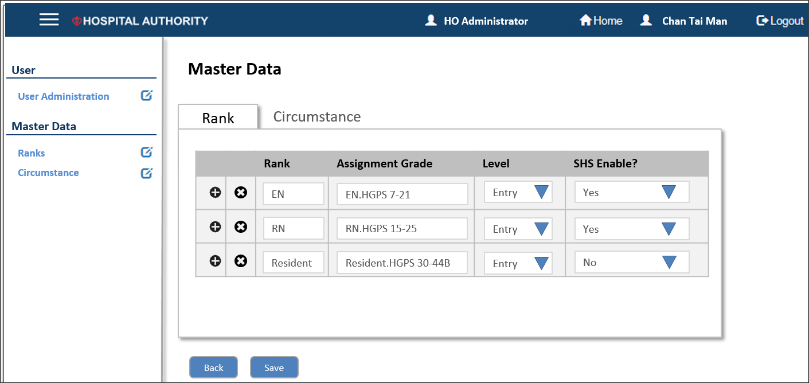

Circumstance Maintenance



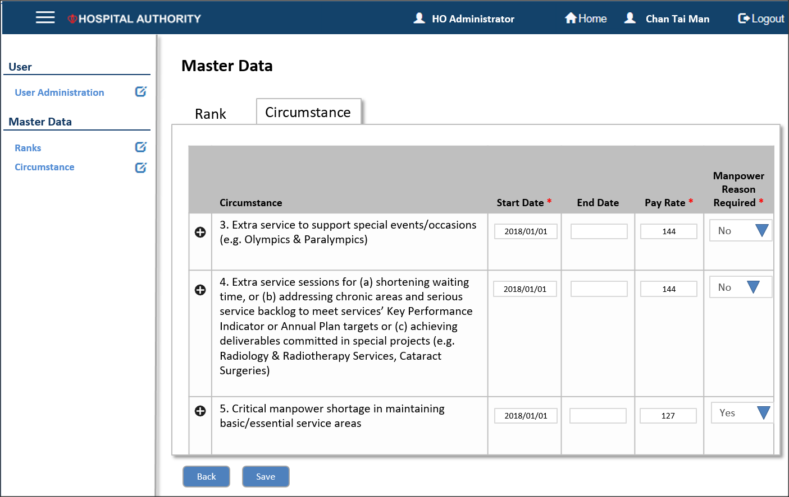

### Cluster Administrator

* + 1. User Administration

1. Search user by Corp ID and click “Find” button. All personal information is retrieved from HCM.

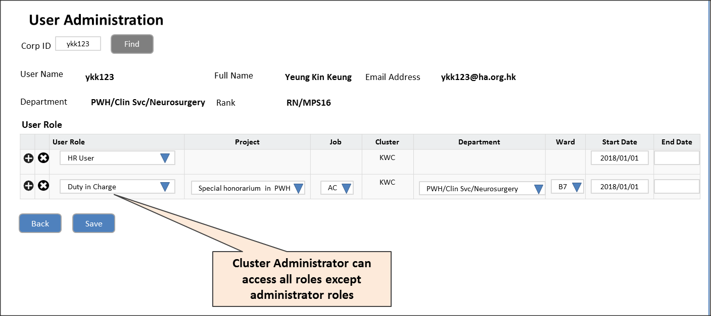

1. Cluster Administrator could access all roles in eClaim system except administrators.

## System Integration / Interface

### Integration with HCM (Phase 1)

HA will provide details on the integration and access details to HCM.

### Interface with SRS (Phase 2)

HA will provide details on the integration to SRS

SRS could provide web service to offer the following data

|  |  |  |
| --- | --- | --- |
|  | **Description** | **Purpose** |
| Department | Complete department list for nurse and doctor | Familiar department name for project initiation. |
| Ward/Location | Up to date ward information, like relationship to department and closing date | Access control for roster planner/ward manager.  Ward is the working location for nurse. |
| Parent Unit/Serving Unit | Staff deployment between hospital and department | Sorting or filtering the available resource in schedule. |
| Roster Duty | Daily staff duties in serving ward | Validation for schedule.   * AL/WO is available for full day * SHS P could be continued with Duty A * SL is not available |
| User Role | Roster planner and Duty I/C Role | Roster planner in SRS would be planner in SHS as well. |
| Staff Rank | Rank for nurse, supporting and clerical staff | Familiar rank name in project initiation.  WM, APN and partial RN are Duty IC for SHS duty |

## Appendix

### User Role vs Function



### HCM Organization List



### Staff Group and Rank List

* Rank will be retrieved from HCM
* Initial setup is provided by policy team and uploaded to eClaim system by data conversion
* Maintained by HO Administrator for any subsequent changes.

### Initial Set Up

* + 1. Rank (Phase 1)



* + 1. Projects, Project Roles, Schedule, Attendance and Initial Used Balance (Phase 1 & 2)

Required further discussion with users during solution design phase. (Refer to open issue 1)

* + 1. Cluster / Department Level Roles (Phase 1)



## Open and Closed Issues for this Deliverable

### Open Issues

| ID | Issue | Resolution | Responsibility | Target Date | Impact Date |
| --- | --- | --- | --- | --- | --- |
|  |  |  |  |  |  |
| 1 | Project data conversion approach |  | HAIT/HRS/Cluster HR |  |  |
|  |  |  |  |  |  |
|  |  |  |  |  |  |
|  |  |  |  |  |  |
|  |  |  |  |  |  |

### Closed Issues

| ID | Issue | Resolution | Responsibility | Target Date | Impact Date |
| --- | --- | --- | --- | --- | --- |
|  |  |  |  |  |  |
| 1 |  |  |  |  |  |
| 2 |  |  |  |  |  |
|  |  |  |  |  |  |
|  |  |  |  |  |  |

## Change Record for Development after HA Endorsement

| ID | Date | Version | Change Reference |
| --- | --- | --- | --- |
|  |  |  |  |
|  |  |  |  |
|  |  |  |  |
|  |  |  |  |
|  |  |  |  |